**Programming Mastery**

**Final Project Report**

**“Gotham Treats”**



**Lecturers:**

Michael Baskara Laksana A S, S.Si., S.Kom., M.Sc.

Dr. Samuel Mahatmaputra T, S.Kom., M.Info.Tech

**Report by:**

Nadja Jasmine Donosepoetro - 2602119184

Dycinta Fedianka - 2602185942

Ajhe Ray Delrian - 2602176894

Nicholas Darmawan - 2602158550

**Table of Contents**

**Chapter I: Project Introduction 2**

1.1. Introduction 2

1.2. Company Overview 3

1.3. Current Business Process 4

1.4. Current Application / Information System 6

1.5. Problems Identified 6

1.6. User’s Requirement and Persona 7

1.7. Proposed Solution 7

**Chapter III: Solution Modelling 9**

3.1. Use Case Diagram 9

3.2. Model Class Diagram 10

3.3. First Cut Class Diagram 11

3.4. Revised Class Diagram 13

3.8. System Sequence Diagram 14

3.11. SQL Statement 19

3.12. UI / UX 22

**Chapter IV: Programming Analysis 22**

4.1. Professional and Ethical Principles in Programming 22

4.2. Database 22

4.3. Algorithms 25

4.4. Data Structures 25

4.5. Graphical User Interface 26

4.6. Object Oriented Programming 29

4.7. Reusability Techniques 29

**Chapter V: Closing 29**

5.1. Conclusion 29

5.2. References 29

# 

# **Chapter I: Project Introduction**

## 1.1. Introduction

This final report is made to fulfil the requirements of the final project for the course: Programming Mastery (ISYS6633003). The final report includes a detailed explanation on the company profile of Gotham Treats, description on UML diagrams, analysis of code, application of object-oriented programming and programming output for the final project.

## 1.2. Company Overview

Gotham Treats is a small local B2C dessert bakeshop based in South Jakarta, Indonesia. Specialising in their own unique take on American classic sweets, Gotham Treats offers a delectable assortment of cookies, milks, dessert boxes, pies, and other sweet treats. Their culinary creations are heavily inspired by their deep appreciation for the goods found in New York City, aiming to bring a touch of that city's flavour and charm to the local market.

Operating within the retail industry, Gotham Treats caters to customers in the food and beverage sector, specifically dessert and bake sector. As a B2C (business-to-consumer) establishment, their primary focus is on selling products directly to individual consumers for personal use. In this case, Gotham Treats offers a delightful array of ice cream, freshly baked goods, and various related treats that satisfy even the most discerning sweet tooth.

What sets Gotham Treats apart is their commitment to quality and attention to detail. Each sweet treat is carefully crafted in small batches, ensuring that every item is made with the utmost care and precision. By baking their goodies fresh, Gotham Treats guarantees the highest level of flavour and freshness, ensuring a delightful experience for their customers.

Currently, Gotham Treats operates in two outlets located in Pakubuwono and Pantai Indah Kapuk (PIK). These strategic locations allow them to reach a wide customer base and cater to the local community's cravings for indulgent desserts. By providing convenient access to their delectable offerings, Gotham Treats has successfully created a local hub for dessert enthusiasts, serving as a go-to destination for New York-inspired treats.

Gotham Treats has four main operating locations: main office, central kitchen, and two retail outlets located in Pakubuwono and Pantai Indah Kapuk. The central kitchen is utilised as the main production location, where kitchen staff will produce the goods. The office is used for managerial activities that include purchasing, finance, marketing & communication activities. The two outlets serve as the retail location where the products will be sold after production.

In summary, Gotham Treats is a small local bakeshop in South Jakarta that brings the essence of New York City's sweets to the local market. With their commitment to quality, fresh ingredients, and a range of delectable treats, they have carved a niche for themselves in the retail industry. With their two outlets strategically positioned in prime locations, Gotham Treats continues to captivate customers and spread joy through their delightful creations.

## 1.3. Current Business Process

With Gotham Treats serving as a retail and dessert shop, their current business process is heavily following Porter’s Value chain where there are five primary activities.

Inbound Logistics

Inbound logistics of the company include vendor management, purchase orders, shipping, and delivery, receiving delivery, storage and inventory management, and quality control. This requires establishing contacts with vendors, reaching agreements, and ensuring the timely supply of raw materials. When orders are submitted, transportation plans are prepared to get materials to the production plant based on production requirements. When the materials are delivered, they are examined for quality and appropriately stored. Quality control ensures that resources reach the production line, and quality control measures are employed throughout the process to maintain flavour, freshness, appearance, and safety standards.

Outbound Logistics

The outbound logistics of Gotham Treats comprise packaging the finished products, processing client orders, completing those orders by selecting the appropriate products from inventory, scheduling shipping and distribution, tracking shipments, and providing customer support. To prepare the packaged products for dispatch, several shipping methods are employed, and records are kept to monitor the process and ensure on-time delivery. Effective outbound logistics ensures that clients receive fresh and high-quality cookies on time, resulting in a successful customer experience and a stable distribution network.

Marketing & Sales

Gotham Treat's marketing and sales strategy includes market research, branding, product creation, advertising, sales channels, pricing, and customer relationship management. The company creates and innovates new products, employs a variety of advertising and promotional methods, selects sales channels and distribution networks, determines pricing strategies, and focuses on building strong customer connections. To identify its target clients and competitors, the company undertakes market research. In a competitive industry, these tactics strive to promote customer happiness and loyalty while also increasing sales and creating demand.

Service

The company’s service activities involve offering an appealing product display, knowledgeable staff, sampling opportunities, customising possibilities, attractive gift wrapping, a speedy checkout procedure, post-purchase support, and opportunities for customer interaction and feedback are all examples of general customer service provided by a dessert company. By tastefully displaying the products, providing information and help, allowing consumers to test products such as cookies, milk, and ice cream. The company focuses on providing a delightful and tailored customer experience. The fast checkout procedure, post-purchase help, and engagement programs make it easier to build client loyalty and contentment.

Operations

Developing recipes, collecting materials and mixtures, planning production, mixing and preparing dough, baking, cooling, and packing, same-day sales and distribution, inventory management, and quality control are all part of a cookie company's general operations. The company develops and improves cookie, milk, ice cream and other product’s recipes, purchases quality ingredients, and creates a production plan to determine the volume and variety of cookies to be produced each day. Before being moulded into cookies and baked in ovens, the dough is produced with precise attention to temperature and baking times. The ingredients are precisely measured and mixed. Once the cookies have cooled, they are wrapped to keep them fresh and safe until delivery. The company develops sales channels and distribution systems in order to give freshly made cookies the same day and ensure speedy delivery to retail stores or other outlets. Inventory levels are regulated to avoid waste while meeting demand, and quality control processes are implemented at every stage of manufacture to ensure consistency in flavour, appearance, and texture. If these operations are carried out quickly, the company may provide customers with freshly baked cookies while maintaining high standards.

## 1.4. Current Application / Information System

The application / information system that is used by Gotham Treats currently has only two softwares: Mekari Talenta and Moka POS. As of now, Gotham Treats has two softwares that are used for the purpose of Human Resources system with Mekari Talenta and Point-of-Sale system with Moka POS.

In this instance, the Head of Operations uses Mekari Talenta to monitor and track employee attendance, performance and salary. While, outlet employees utilise Moka POS to input and enter in the sales made from the outlet in a certain period.

Specifically, in terms of managing inventory and production, there is no central system and instead, the outlet employees are seen with papers to document their production process and the products baked from their outlet. Furthermore, from those papers, they document it onto an Excel sheet on their laptop. With that said, Gotham Treats does not facilitate an inventory management and production system that is integrated digitally.

## 1.5. Problems Identified

Inventory Management:

The absence of an inventory management system at Gotham Treats poses challenges such as manual tracking, inaccurate stock levels, inefficient reordering processes, limited insights, and operational inefficiencies. Gotham Treats currently tracks their inventory manually on paper, then the purchasing team will put it into a journal (app).

Sales Insight:

Gotham Treats also does not have sales insights on their system, which hampers their ability to improve performance and cater to customer needs. Without the means to analyse sales patterns, customer preferences, and product performance, Gotham Treats lacks crucial insights that could guide decision-making processes, such as optimising their offerings, identifying popular items, and tailoring their strategies to enhance customer satisfaction.

Managing Branches:

The issue for Gotham Treats as it grows its business is it is hard to manage sales and trends at each outlet. Finding patterns, trends, and differences in branch performance becomes challenging without a system in place to give centralised visibility and analysis of sales data across their locations. Due to this, Gotham Treats experience difficulty in managing their branches.

## 1.6. Data Collection Evidence

To further understand and analyse the company’s operations and the roles in the company, an interview and an observation was conducted. In late February, the group had emailed Gotham Treat’s email to arrange an interview with the staff.

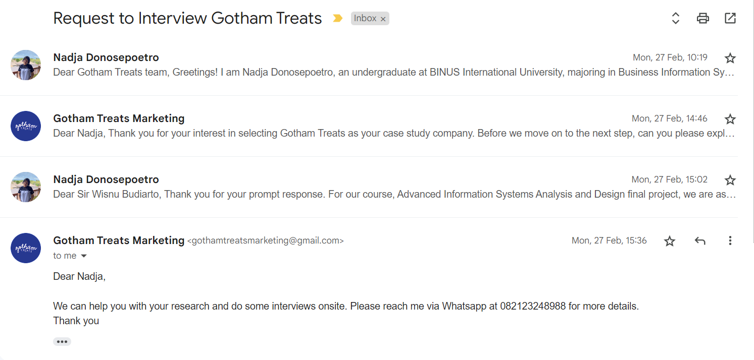

By exchanging emails, the group was able to schedule an interview time in early March to inquire regarding operations and gain an understanding on how Gotham Treats operate as a dessert bake shop.

We interviewed Sir Andi Buana, Head of Operations, who manages and supervises the production, outlet operations and inventory management of Gotham Treats. We were able to ask regarding his responsibilities and habits as Head of Operations as well as ask regarding the operations to get a greater understanding of how Gotham Treats operates. As he is Head of Operations, it is noted that he often moves around from the main office, central kitchen and outlet.

Aside from collecting data and insight from the interview, the group had also visited the outlet two times to conduct observation. We gained from our observations on how the outlet employees operate, bake and conduct their sales into the system.

## 1.7. User’s Requirement and Persona

**User Requirements**

1. Inventory Tracking and Management: The system should automate inventory tracking, eliminating manual paper-based processes. It should provide accurate and real-time inventory information, including product details, quantities, locations, and stock availability. Users should be able to search and filter inventory based on various parameters such as product name, category, or supplier.
2. Purchase Order Management: The system should streamline purchase order management processes. Users should be able to create, modify, and track purchase orders, specifying product quantities, selecting suppliers, and setting delivery dates. It should indicate the status of purchase orders from pending to received. Users should be able to update purchase orders as needed, including adding or removing items, adjusting quantities, or changing delivery details.
3. Purchase Order Management: Creation, modification, and tracking of purchase orders. Ability to specify products, quantities, suppliers, and delivery dates. Updates and status tracking of purchase orders.
4. User-Friendly Interface: Intuitive interface for easy navigation and efficient data entry.

**User Persona**

* Name: Andi Buana
* Company: Gotham Treats
* Role: Head of Operations
* Company Description: Gotham Treats is a dessert bake shop company with two outlets.

Goals:

* Efficient inventory tracking and management
* Improved production monitoring
* Streamlined procurement processes

Current Challenges:

* Manual inventory tracking
* Lack of reporting and analytics
* Educational Background: Andi holds a Bachelor's degree in Business Administration with a focus on Supply Chain Management from a reputable university.

Andi is in charge of guaranteeing efficient inventory management, data-driven decision making, and efficient purchase order administration at Gotham Treats. The organisation is now having issues with manual inventory management and a lack of reporting and analytics tools.

## 

## 1.8. Proposed Solution

Our proposed solution for Gotham Treats is to implement a digitised inventory management system that automates inventory tracking, production monitoring, and procurement processes. This system will eliminate the need for manual paper-based tracking, ensuring accurate and real-time inventory information. It will enable the actors at Gotham Treats to easily update stock levels, automate reordering based on predefined thresholds, and streamline inventory management.

Additionally, we will integrate a comprehensive sales insights module into the system. This module will capture and analyse sales data, customer preferences, and product performance. By leveraging data analytics, Gotham Treats will gain valuable insights into sales patterns, popular items, and customer preferences. These insights will inform data-driven decision-making, enabling the optimization of offerings, tailored strategies, and improved customer satisfaction. Furthermore, we will provide a centralised system that offers visibility and analysis of sales data across all branches, enabling outlets and central management to access real-time sales information, identify trends, and compare branch performance. This centralised visibility will facilitate effective decision-making, resource allocation, and standardisation efforts across branches, addressing the challenges associated with managing multiple locations. Overall, our proposed solution will streamline operations, improve efficiency, and provide valuable data-driven support to help Gotham Treats thrive and grow.

# 

# **Chapter II: Solution Modelling**

## 2.1. Use Case Diagram

## 

For the Advanced Information Systems Design and Analysis course, we have tailored our use cases for six different actors. The Head of Operations has access to 13 use cases, Kitchen has eight, Purchasing has eight, Outlet has five, Finance has one, and Driver has one. These use cases are designed to streamline operations and support specific tasks and responsibilities within each role.

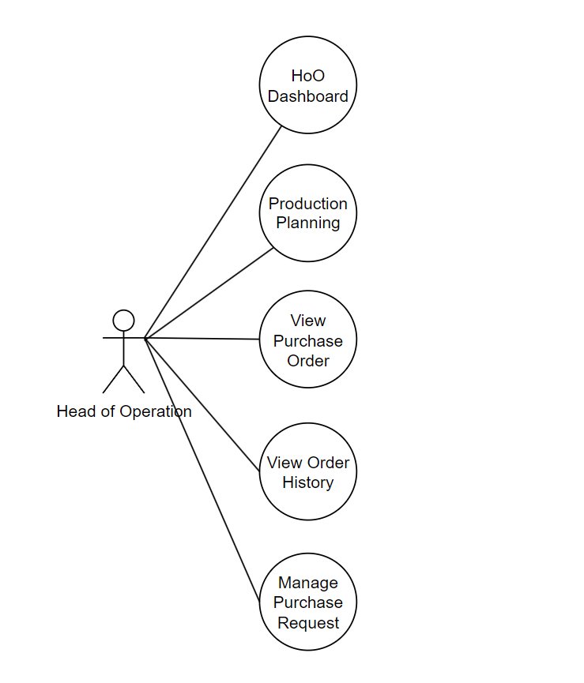

For the Programming Mastery course, our scope is focused on implementing the 5 different use cases, which are HoO Dashboard, Production Planning, View Purchase Order, View Order History, and Manage Purchase Request that are all accessed by the Head of Operations.

The use case are as followed:

* Head of Operations Dashboard - view information on the upcoming tasklist, current status on production sequence, sales order analytics of the month from total revenue, total sales from each outlet as well as recent orders.
* Production Planning - do decision making and input the make-to-stock quantity and deliverable quantity for each outlet for all products.
* View Purchase Order - view stored purchase order along with previewing purchase order details associated with each purchase order.
* View Order History - view order information that is stored on the database and be able to preview order details associated with each order.
* Manage Purchase Request - view pending purchase request.

## 2.2. Domain Model Class Diagram

## 

For the Advanced Information Systems Design and Analysis course, we created a complete Domain Model Class Diagram for us to manage the data for our whole inventory management solution.

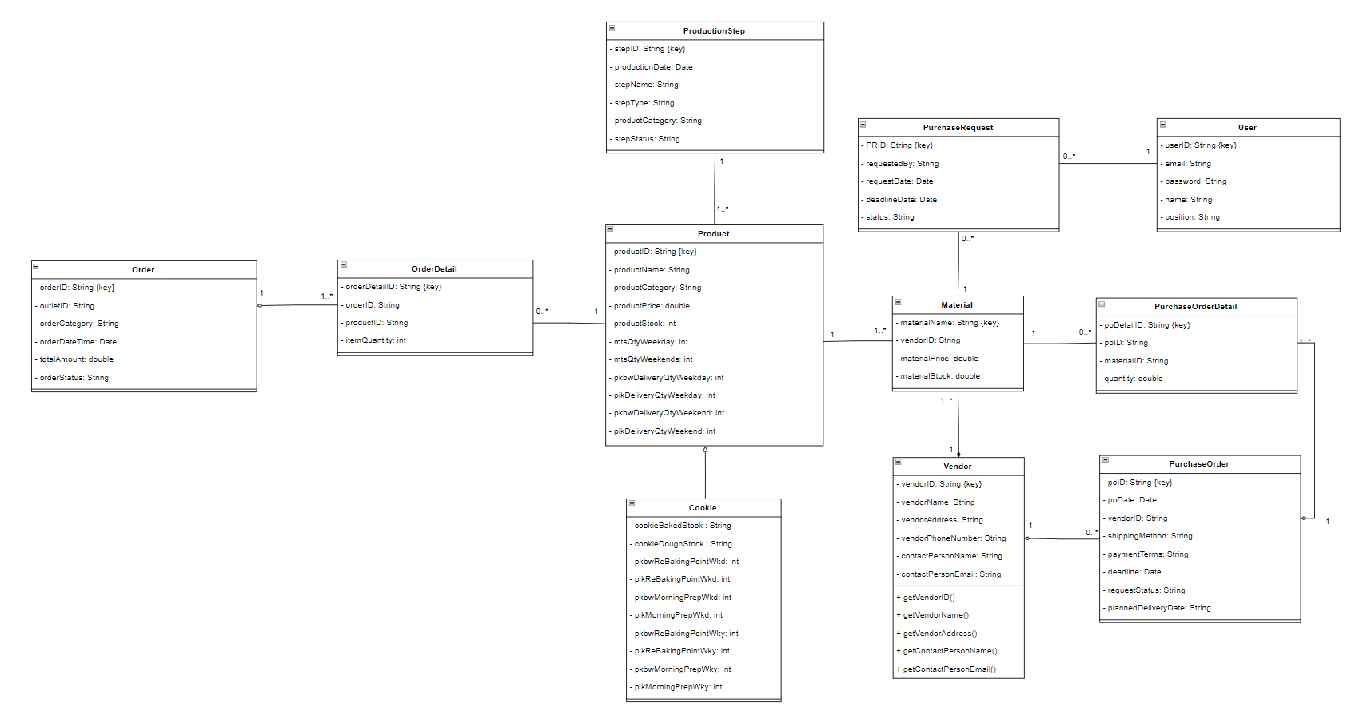

For the Programming Mastery course, we focused on implementing 11 different model classes, which are Product, Cookie, Material, Order, Order Detail, Purchase Order, Purchase Order Detail, User, Production Step, Purchase Request, and Vendor.

The 11 different model classes utilise object-oriented programming where those individual classes have their own defined attributes and methods. Through instantiating in Java programming, objects are able to be created and attributes are able to be accessed onto the console and JFrame.

The model classes are instantiated in the Controller.java where it serves as an intermediary between the available function and the system interaction by the user. When the end-user interacts with the system such as by clicking using a mouse or clicking on a particular button, Controller class is called with a specific method that then calls a specific SQL statement from calling a particular method from the dataAccess class. Within my Controller class, a respective model class is instantiated and returned and hence with that, the concept of class in object-oriented programming is able to be demonstrated and applied.

## 2.3. First Cut Class Diagram

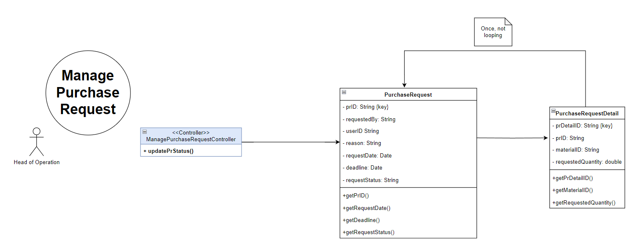

## 2.4. Revised Class Diagram

Revised Class Diagram Programming Scope

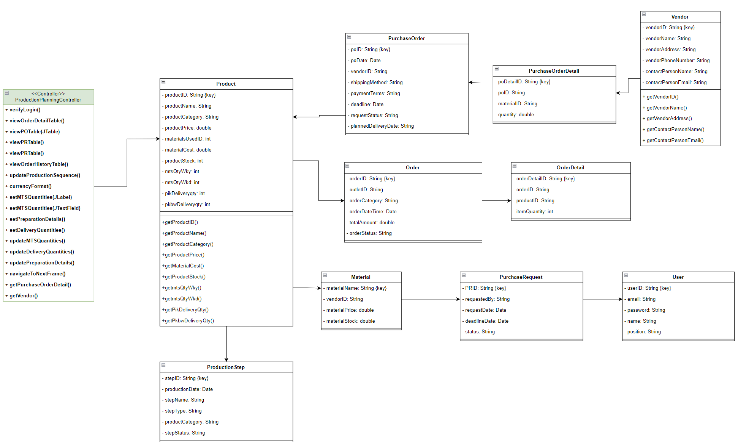

## 2.4. System Sequence Diagram

The diagram above is our system sequence diagram created for when the Head of Operations will conduct the production planning phase, and how the system will interact with the user.  
  
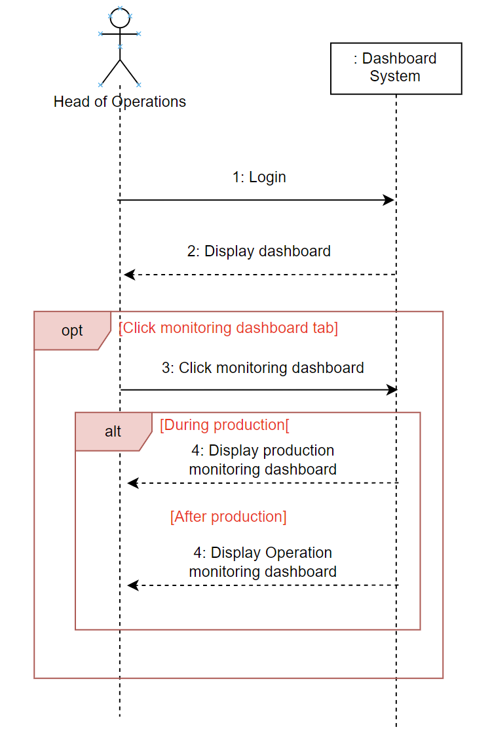

This diagram shows how our dashboard system will interact with the Head of Operations screen for our HoO dashboard’s use case.

2.5. Multilayer Diagram  
1.Production Planning  
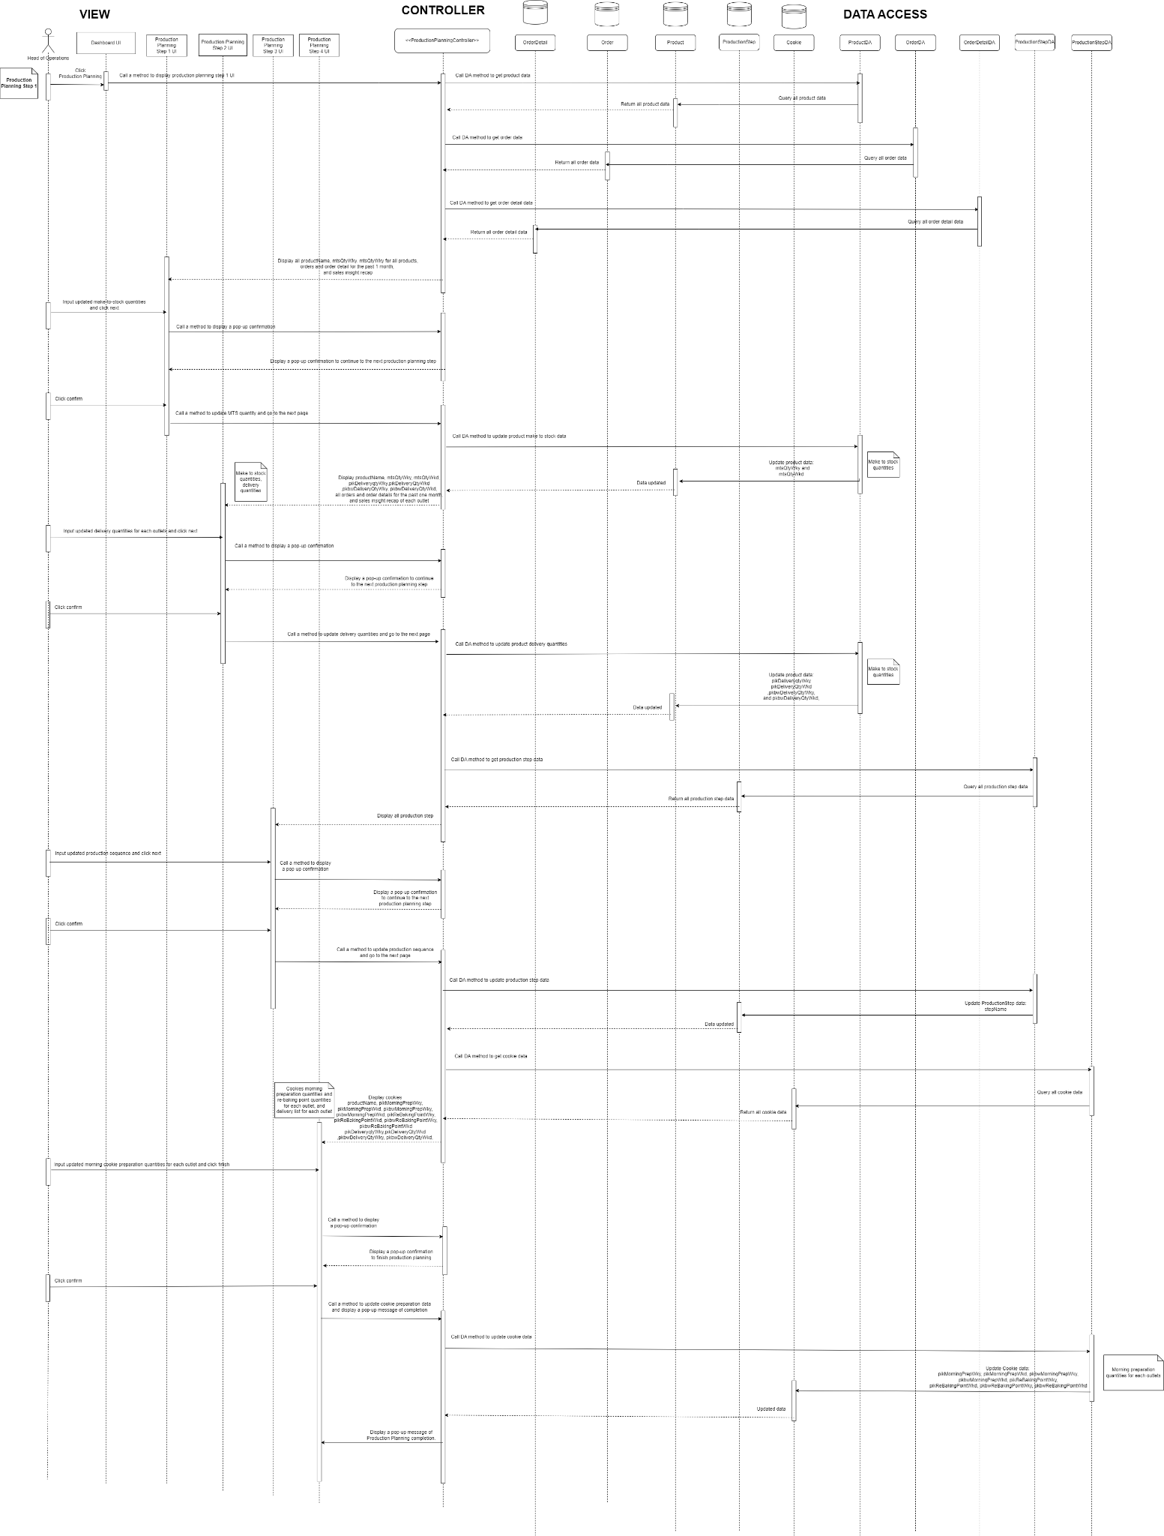  
  
3. Head of Operations Dashboard

## 

## 

3.10. Communication Diagram  
4. Production Planning  
  
5. View Purchase Request



## 

## 2.5. SQL Statement

Within the programming scope defined earlier from the use case diagram, below are 18 SQL statements used in the DataAccess class where INSERT, SELECT, UPDATE and DELETE are used in the SQL statement to retrieve and modify data from the database.

| **Method** | **SQL Statement** |
| --- | --- |
| public String getLoginDetails() | SELECT * FROM userdb WHERE Email=? AND Password=? |
| public String getProductData(String productName) | SELECT * FROM product WHERE productName='"+productName+"' |
| public String getProductData2(String productID) | SELECT * FROM product WHERE productID ='"+productID+"'" |
| public String getUserData() | SELECT * from userdb |
| public String getPurchaseOrderData() | SELECT * from purchaseorder |
| public String getPurchaseRequestData() | SELECT * from purchaserequest |
| public String getOrderData() | SELECT * from orders |
| public String getOrderDetailData() | SELECT * from orderdetail |
| public String getVendorData(PurchaseOrder PO) | SELECT * FROM vendor WHERE vendorID = '" + PO.getVendorID() + "' |
| public String createUserDetails(String userID, String userEmail, String userPassword, String userName, String userPosition) | INSERT INTO userdb (userID, Email, Password, Name, Position) VALUES ('" + userID + "', '" + userEmail + "', '" + userPassword + "', '" + userName + "', '" + userPosition + "') |
| public String updateUserDetails(String userID, String userPassword, String userPosition) | UPDATE userdb SET Password = '" + userPassword + "', Position = '" + userPosition + "' WHERE userID = '" + userID + "' |
| public String deleteUserDetails(String userID) | DELETE FROM userdb WHERE userID = '" + userID + "' |
| public String getPurchaseOrderDetailData(PurchaseOrder PO) | SELECT * FROM purchaseorderdetails WHERE poID = '" + PO.getPurchaseOrderID() + "'" |
| public String updateProductionStep(String firstPS, String secondPS, String thirdPS, String fourthPS, String fifthPS, String sixthPS, String seventhPS, String eighthPS) | "UPDATE productionStep " +  "SET stepName = CASE " +  " WHEN stepID = 1 THEN '" + firstPS + "' " +  " WHEN stepID = 2 THEN '" + secondPS + "' " +  " WHEN stepID = 3 THEN '" + thirdPS + "' " +  " WHEN stepID = 4 THEN '" + fourthPS + "' " +  " WHEN stepID = 5 THEN '" + fifthPS + "' " +  " WHEN stepID = 6 THEN '" + sixthPS + "' " +  " WHEN stepID = 7 THEN '" + seventhPS + "' " +  " WHEN stepID = 8 THEN '" + eighthPS + "' " +  "END, " +  "productCategory = CASE " +  " WHEN stepName = '" + firstPS + "' THEN productCategory " +  " WHEN stepName = '" + secondPS + "' THEN productCategory " +  " WHEN stepName = '" + thirdPS + "' THEN productCategory " +  " WHEN stepName = '" + fourthPS + "' THEN productCategory " +  " WHEN stepName = '" + fifthPS + "' THEN productCategory " +  " WHEN stepName = '" + sixthPS + "' THEN productCategory " +  " WHEN stepName = '" + seventhPS + "' THEN productCategory " +  " WHEN stepName = '" + eighthPS + "' THEN productCategory " +  "END, " +  "stepType = CASE " +  " WHEN stepName = '" + firstPS + "' THEN stepType " +  " WHEN stepName = '" + secondPS + "' THEN stepType " +  " WHEN stepName = '" + thirdPS + "' THEN stepType " +  " WHEN stepName = '" + fourthPS + "' THEN stepType " +  " WHEN stepName = '" + fifthPS + "' THEN stepType " +  " WHEN stepName = '" + sixthPS + "' THEN stepType " +  " WHEN stepName = '" + seventhPS + "' THEN stepType " +  " WHEN stepName = '" + eighthPS + "' THEN stepType " +  "END" |
| public String updateProductMTSQuantities(String productName, String mtsQtyWeekdays, String mtsQtyWeekends) | UPDATE product SET mtsQtyWeekdays = '" + mtsQtyWeekdays + "', mtsQtyWeekends = '" + mtsQtyWeekends + "' WHERE productName = '" + productName + "' |
| public String updateDeliveryQuantities(String productName, JTextField mtsWeekdaysPKBW, JTextField mtsWeekdaysPIK, JTextField mtsWeekendPKBW, JTextField mtsWeekendPIK) | UPDATE product SET pkbwDeliveryQtyWky = '" + mtsWeekdaysPKBW.getText() + "', pikDeliveryQtyWky = '" + mtsWeekdaysPIK.getText() + "', pkbwDeliveryQtyWkd = '" + mtsWeekendPKBW.getText() + "', pikDeliveryQtyWkd = '" + mtsWeekendPIK.getText() + "' WHERE productName = '" + productName + "' |
| public String updatePIKPreparationDetails(String productName, JTextField MPWdy, JTextField RPWdy, JTextField MPWkd, JTextField RPWkd) | UPDATE product SET pikMorningPrepWky = '" + MPWdy.getText() + "', pikReBakingPointWkky = '" + RPWdy.getText() + "', pikMorningPrepWkd = '" + MPWkd.getText() + "', pikReBakingPointWkd = '" + RPWkd.getText() + "' WHERE productName = '" + productName + "' |
| public String updatePKBWPreparationDetails(String productName, JTextField MPWdy, JTextField RPWdy, JTextField MPWkd, JTextField RPWkd) | UPDATE product SET pkbwMorningPrepWky = '" + MPWdy.getText() + "', pkbwReBakingPointWkky = '" + RPWdy.getText() + "', pkbwMorningPrepWkd = '" + MPWkd.getText() + "', pkbwReBakingPointWkd = '" + RPWkd.getText() + "' WHERE productName = '" + productName + "' |

## 

## 

# **Chapter IV: Programming Analysis**

## 4.1. Professional and Ethical Principles in Programming

In software development, there is a professional principle such as “Don’t repeat yourself” DRY where it limits repetition in coding. Example of the DRY principle is where a method is defined in the class and the method is called multiple times instead of the content of the code being called.

The DRY principle is used specifically in the dataAccess class where it has methods to get a specific SQL statement. The methods in that class are called onto the JFrame and re-used in several JFrames.

Another example of DRY principle that is shown in programming is in the Controller class where the method navigateToNextFrame(JFrame currentFrame, JFrame nextFrame) is created to ease the activity of closing the current JFrame that is shown and to open the next JFrame. By creating this method, it reduces the repetition of the code and made the code more clean and efficient.

Instead of writing the code below multiple times in different frame:

currentFrame.setVisible(false);

nextFrame.setVisible(true);

A method called navigateToNextFrame(JFrame currentFrame, JFrame nextFrame) is created which includes the code above in the Controller class. So in the JFrame, I am able to call the method to transition from the current frame to the next frame to be shown to the end-user. Example are as followed:

private void jLabel3MouseClicked(java.awt.event.MouseEvent evt) {

controller.navigateToNextFrame(this, new productionPlanStep1());

}

By calling navigateToNextFrame(JFrame currentFrame, JFrame nextFrame) to be used as a method to navigate and transition end users to the next JFrame shown.

Aside from that, there are multiple times where the methods in dataAccess class is called and used to return the “SELECT * from ${a specific table}” and then continued on with a specific SQl statement such as “WHERE …”. By calling a method that is constructed in the dataAccess class, it showcases that repetition is reduced as the method is used to minimise repetitiveness in the code.

## 4.2. Libraries

To implement and build a digitised inventory system, there are three libraries that are used in the Java project. The three libraries are RSCalendar.jar, mysql-connector-j-8.0.31.jar and JDK 18.

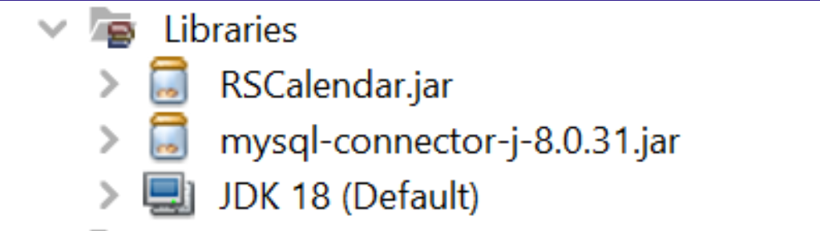

The three libraries are used as followed:

* RSCalendar.jar - open source jar for improved GUI components.
* mysql-connector-j-8.0.31.jar - provides connectivity to mySQL.
* JDK 18 (Default) - Java Developer Kit has tools to write Java program and be used to run the Java Virtual Machine (JVM) and JRE (Java Runtime Environment).

## 4.3. Database

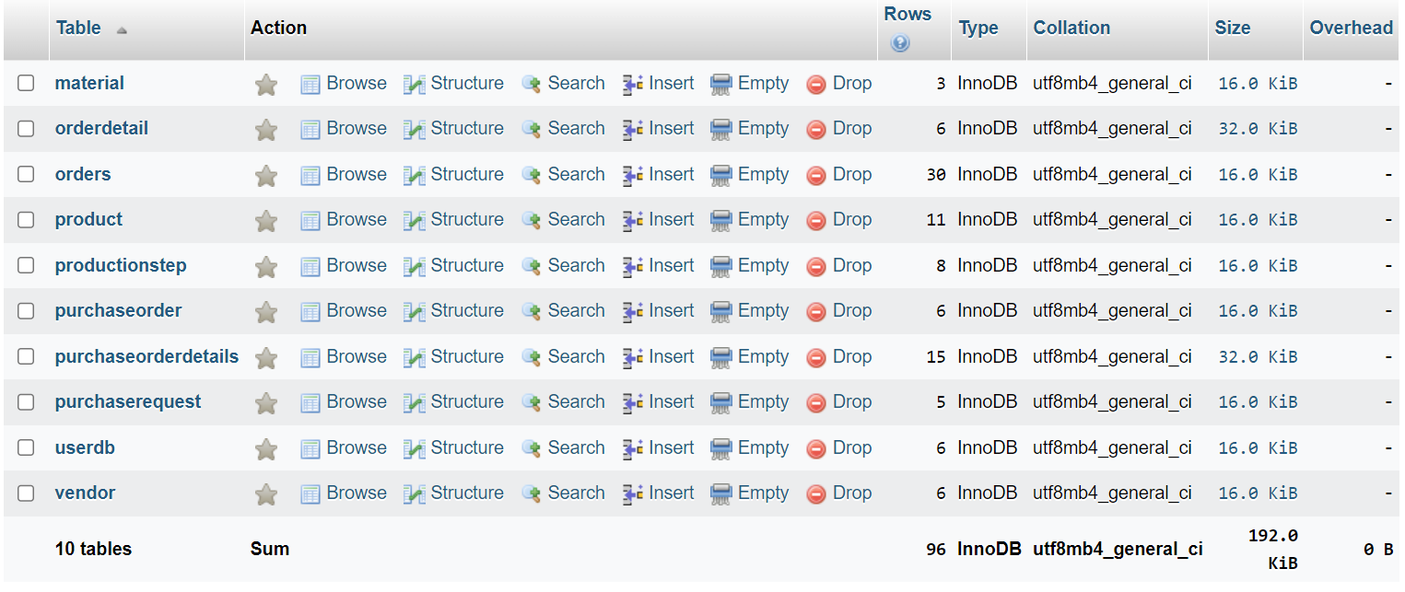

To effectively handle and update data in the programming application, a database management system is utilised. This system stores and maintains a database for the application software, such as XAMPP myPhpAdmin, using SQL as the programming language. This allows for the storage, updating, and deletion of large data sets. The data can then be read and displayed on the user interface (JFrame) for the end-user. By employing tools like XAMPP myPhpAdmin, the system efficiently stores and utilises data, enabling successful business processes through the support of the database and programmed algorithms.

In myPhpAdmin, 10 tables stored in a database are created as they are then retrieved from the dataAccess class using various methods to return the specific SQL statement. The 10 tables are:

* `material` - table to store material good information to create the product.
* `orderdetail` - table to store order details for each existing order.
* `orders` - table to store orders from point-of-sale.
* `product`- table to store product information.
* `productionstep` - table to store the 8 steps in the flow of production.
* `purchaseorder`- table to store purchase order.
* `purchaseorderdetails` - table to store purchase order details for each existing purchase order created.
* `purchaserequest` - table to store purchase order.
* `userdb` - table to store user information.
* `vendor` - table to store vendor information.

The XAMPP myPhpAdmin Database is able to be accessed into the Java using mysql-connector.jar and the databaseConnector Java class where the method getConnection() is used to establish a connection to the XAMPP myPhpAdmin that is stored in MySQL language as database using the mysql-connector.jar.

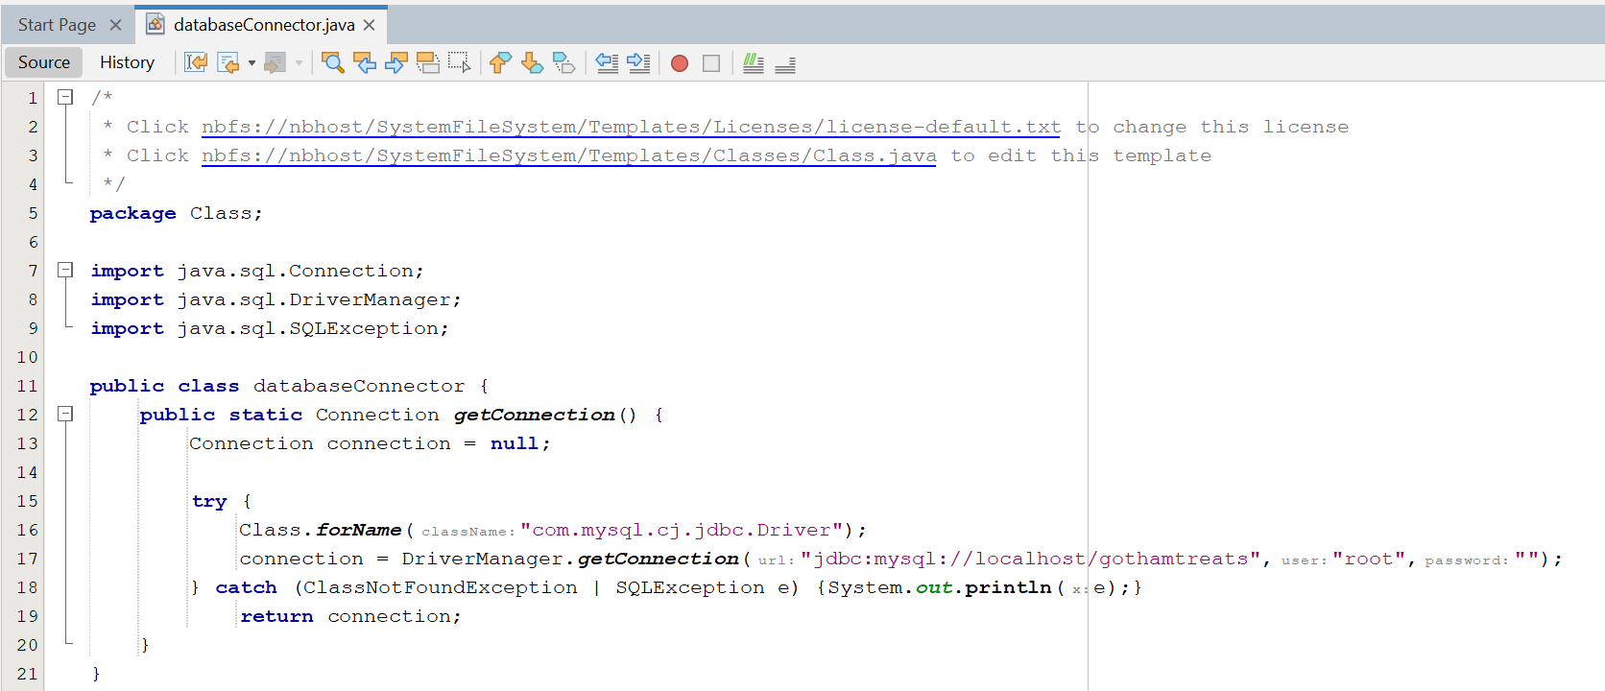

## 4.4. Model View Controller

A programming framework that was deeply embedded and applied in our programming final project is MVC (Model, View, Controller). MVC is a programming framework which is separated into 3 main components; model referring to the class, view referring to the graphical user interface seen by the end-user and the controller referring to the functions or algorithms. All 3 components serve an important role in building and running the software application.

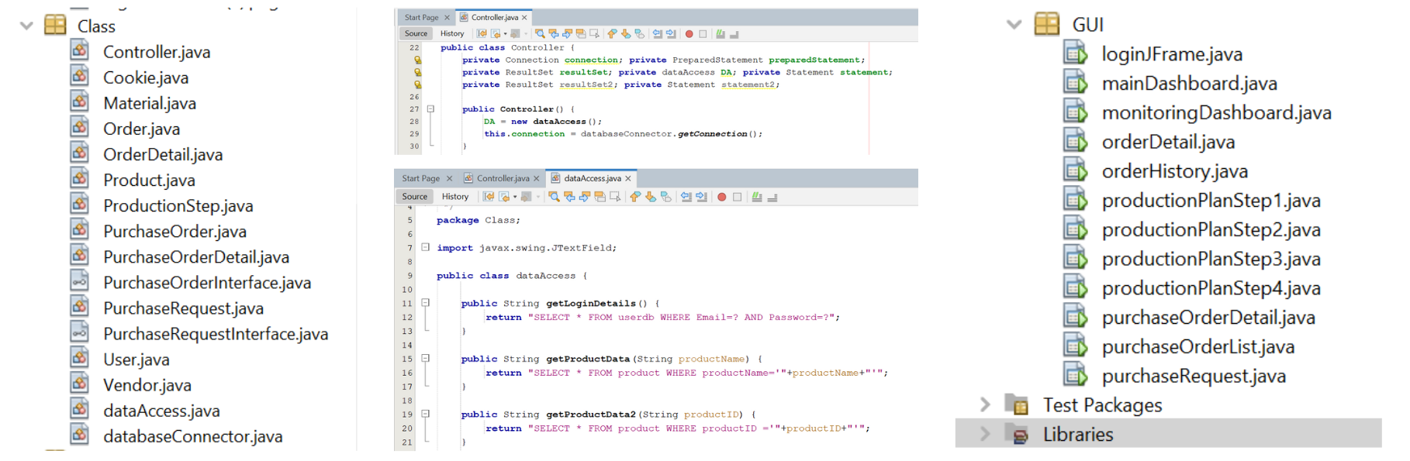

With the figure seen above, on the left hand-side, the folder `Class` consists of 1 Controller (Controller.java), 1 Data Access (dataAccess.java), 1 Database Connector (databaseConnector), 11 model classes (Cookie.java, Material.java, Order.java, OrderDetail.java, Product.java, ProductionStep.java, PurchaseOrder.java, PurchaseOrderDetail.java, PurchaseRequest.java, User.java, Vendor.java), as well as 2 interfaces (PurchaseOrderInterface.java and PurchaseRequestInterface.java) that will be further elaborated in the Object-Oriented Programming section of the report.

While, on the right-hand side of the figure, there is a folder named `GUI` which includes all the 13 JFrames shown through the programming project such as loginFrame.java, mainDashboard.java, monitoringDashboard.java, userDetail.java, orderDetail.java, orderHistory.java, productionPlanStep1.java, productionPlanStep2.java, productionPlanStep3.java, purchaseOrderDetail.java, purchaseOrderList.java, purchaseRequest.java.

With the model, view and controller components defined, it is possible to implement in all the JFrames as the JFrame which is the view component instantiates the controller (Controller.class) and calls the respective methods. With the respective methods in the controller, it instantiates several model classes and calls specific methods such as get${attributes} from the respective model classes. Following that pattern, in the controller, the dataAccess class is instantiated and methods from the dataAccess class can be called onto the controller in which the SQL statements can be returned in where it can be connected to the database and the controller is able to call and retrieve specific data from the database. By applying this technique, the framework MVC is possible to be seen throughout the programming of this software application.

## 

## 4.4. Algorithms

1. Login Validation and Verification Algorithm

*verifyLogin() including validateLoginFields*

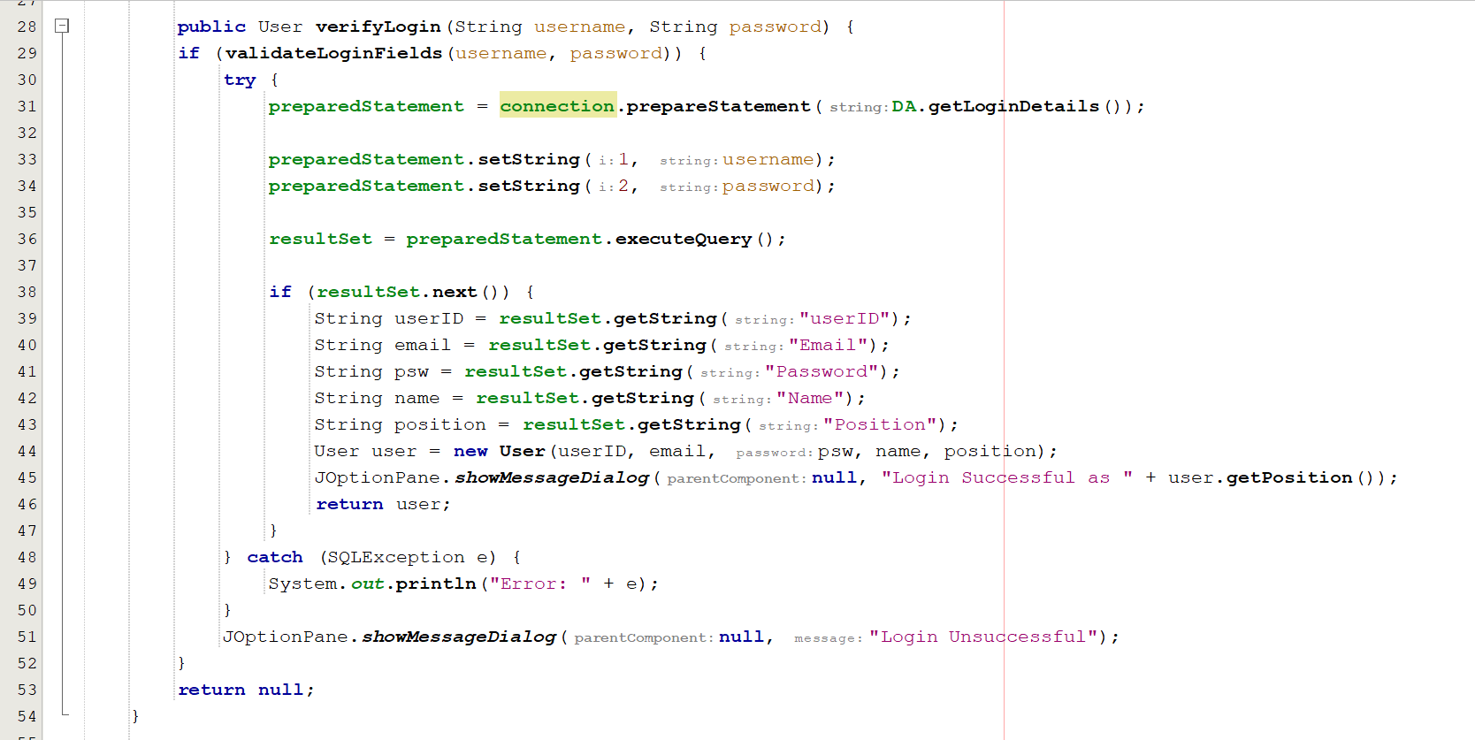

*validateLoginFields() with the parameter of String variables associated to Login details*

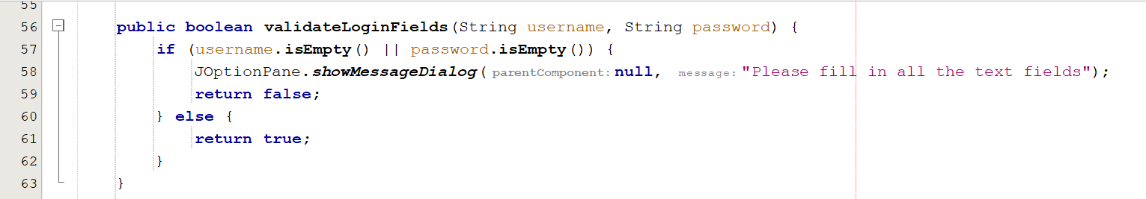

Above is the code that showcases the algorithm to verify the login details using user information from the database table of `userdb` where it is being checked. If the information matches, the user is greeted with a notification that they successfully logged in and they are considered as an authorised user that is able to access the following frame, mainDashboard.java.

In this case, the algorithm checks whether the user matches with the user information and if verified, the user is logged and in this case, logged in as the Head of Operations and a User class is instantiated. If the user does not match with the user information stored from the database, the user is notified with a notification that the login was unsuccessful, hence informing the result of the verification to the end-user.

Aside from verification, validation is also implemented into this as when the button “LogIn” is clicked by the end user, the system checks whether the text field for username and password has been filled. If it has been filled, it will go to the verification process. However, if one or both of the text fields has been left empty, there will be a notification that informs the user to fill in both text fields. With this login verification algorithm created, it prepares error handling in which the user inputs incorrect or leave empty field on the text field as well as informs the user regarding the result of the verification process that is done by the system.

## 

1. User Detail CRUD Operations

*createAccountBtnActionPerformed() including validateUserFields() and createUserDetails()*

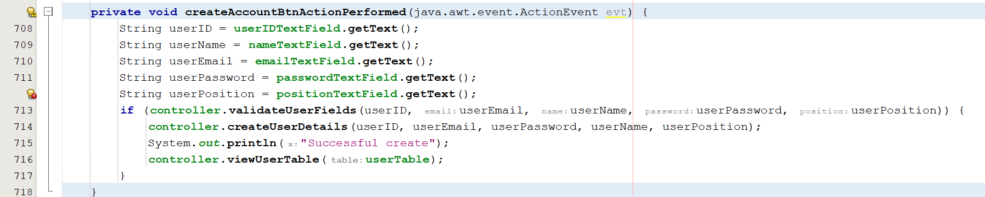

*readAccountBtnActionPerformed() including getUser() to instantiate user object*

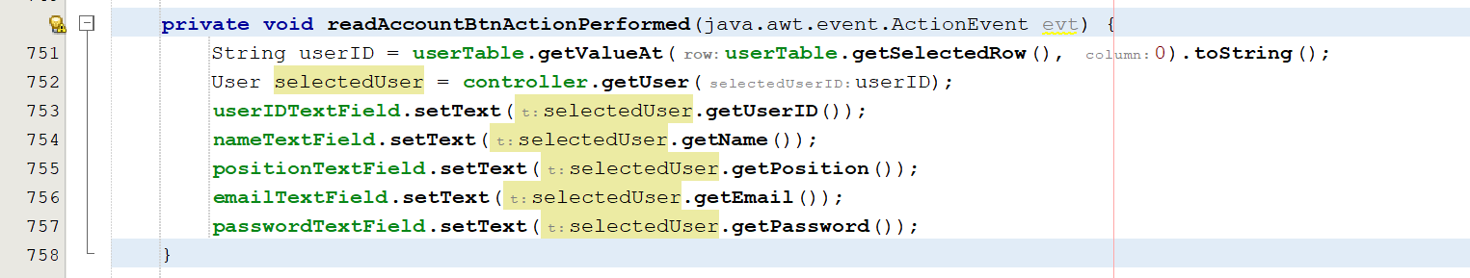

*updateAccountBtnActionPerformed() including validateUserFields() and updateUserDetails()*

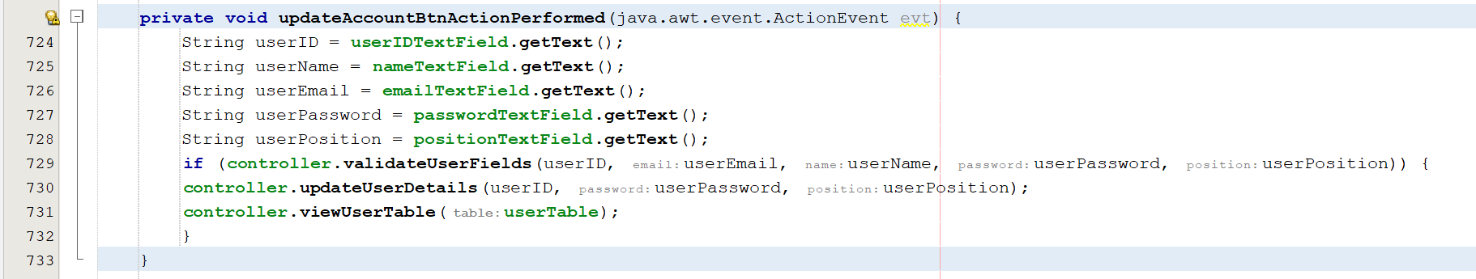

*deleteAccountBtnActionPerformed() including deleteUserDetails()*

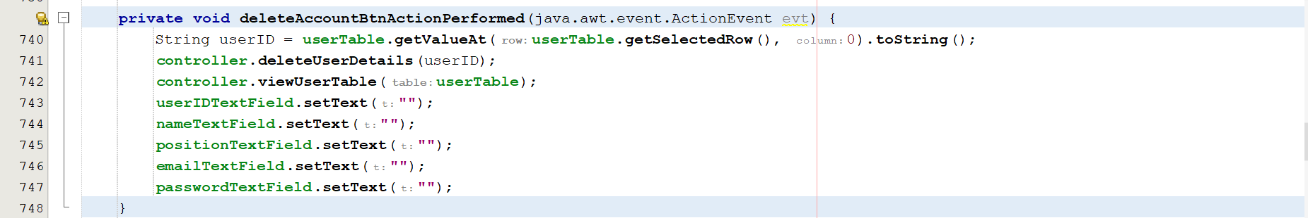

*validateUserFields() with the parameter of String variables associated to User details*

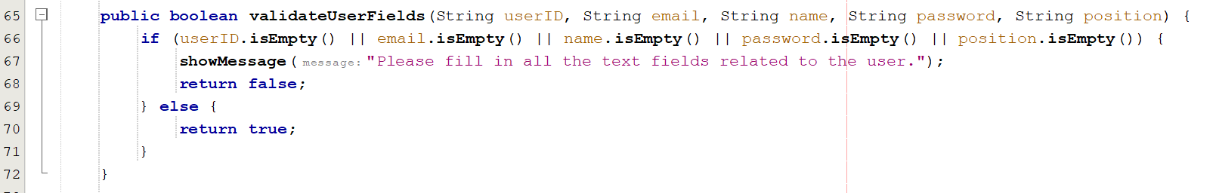

It is believed that in a software application or system, there should be 4 basic functions that a user can do which is creating data, reading data, updating and deleting data. This can be further simplified by the acronym, CRUD which represents those four functions.

The concept CRUD is applied in our programming and can be specifically seen in the JFrame userDetail.java where a table is used to showcase all the data stored from the table ‘userdb’ onto the screen in which the Head of Operations are able to read the data and manage the user information.

With the JFrame presented and the code created, the Head of Operations is able to create a new user and store it onto the database, update a user’s details such as the position and password as well as delete the user account itself.

By creating various methods in the dataAccess class relating to CRUD, various SQL statements were used from INSERT, SELECT, UPDATE and DELETE and called onto the controller to perform specific functions such as creating new user account, selecting (and reading) a specific user account from the table, updating user information as well as deleting a user account. Through developing each method for each function the user can do, CRUD is able to be showcased onto the software application and the Head of Operations is able to manage the user information accordingly.

Aside from that, furthermore, validation is developed onto this CRUD algorithm. As when the user clicks on a specific button on the screen, the validation on whether all fields have been filled is checked and if it returns true (referring that all the text fields have been filled), the specific CRUD operation will occur. However, if the validation algorithm returns false, the user is notified that they must fill in all the text-fields.

## 

## 4.5. Data Structures

The data structure used in programming is arraylist. Arraylist is a resizable array and can be fitted to be flexible to its usage. It is applied specifically in the Controller.java and PurchaseOrder class.

With the understanding that a customer can have many order details that are made from selecting an item along with the quantity and putting it under one order, the programming for order and order detail is considered. It can be seen from the class diagram that there is multiplicity specifically involved in order and order detail in which order detail is aggregated to order. It is noted that order can have a one-to-many relationship with order detail while order detail has one-to-one relationship. This thus proves how our understanding is reflected onto our class diagram.

With that, our realisation from the class diagram into programming is only possible through arraylist as the number of order details is resizable according to customer themselves and once the customer is satisfied, the customer can choose to check-out and all the order details that have been previously instantiated is stored under one specific orderID which then relates to one order class.

Although, in our programming assumption and scope, the Point-of-Sale system is not included, the data such as order and orderDetails is still used internally for the Head of Operations to do decision-making. After evaluating and reading the data, the Head of Operations is able to do wiser decision-making and determine an appropriate quantity of the production stock.

Hence, in that case, the data structure of arraylist is used to retrieve a specific order detail from the database that matches the orderID that can be retrieved from the specific method of getOrderID() from the model class. With that, ArrayList is used to retrieve the order details associated with a specific order we wish to retrieve in our system.

It can be seen below in Figure 4: Controller.java, that ArrayList is instantiated in line 433 and the recent orderDetail object instantiated seen from line 444 is instantiated into the orderDetailsArrayList.add(orderDetail) - showcasing that that current orderDetail object is added into that specific ArrayList and then assigned into the Order Object by the method of setOrderDetail with the orderDetailsArrayList as the parameter. It signifies that the ArrayList, orderDetailsArrayList which includes the current orderDetail object is assigned into the model class and object of order.

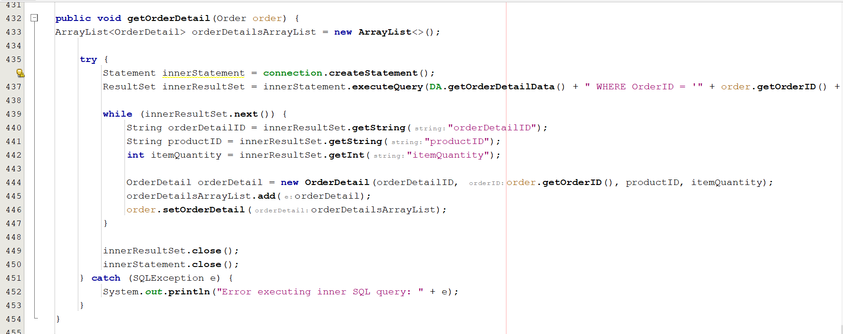

*Controller.java*

*Another example in which ArrayList is used is where a purchaseOrder can have one-to-many purchaseOrderDetails in where the user is supplying many items with one purchaseOrder issued. The ArrayList is used below in line 48 and line 52 in the model class of PurchaseOrder.java to get and set the ArrayList of poDetails into the class. In line 48, the ArrayList is assigned into the modal class of PurchaseOrder with the method setPurchaseOrderDetails with the parameter of the ArrayList<PurchaseOrderDetail> poDetails. While, in line 53, the getPurchaseOrderDetails() method is used to return the ArrayList.*

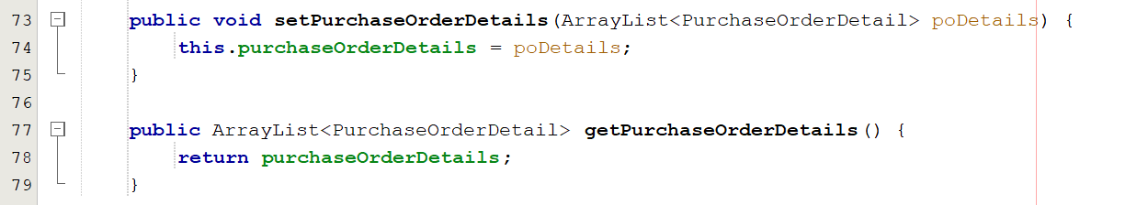

*PurchaseOrder.java*

## 4.6. Graphical User Interface and UI/UX

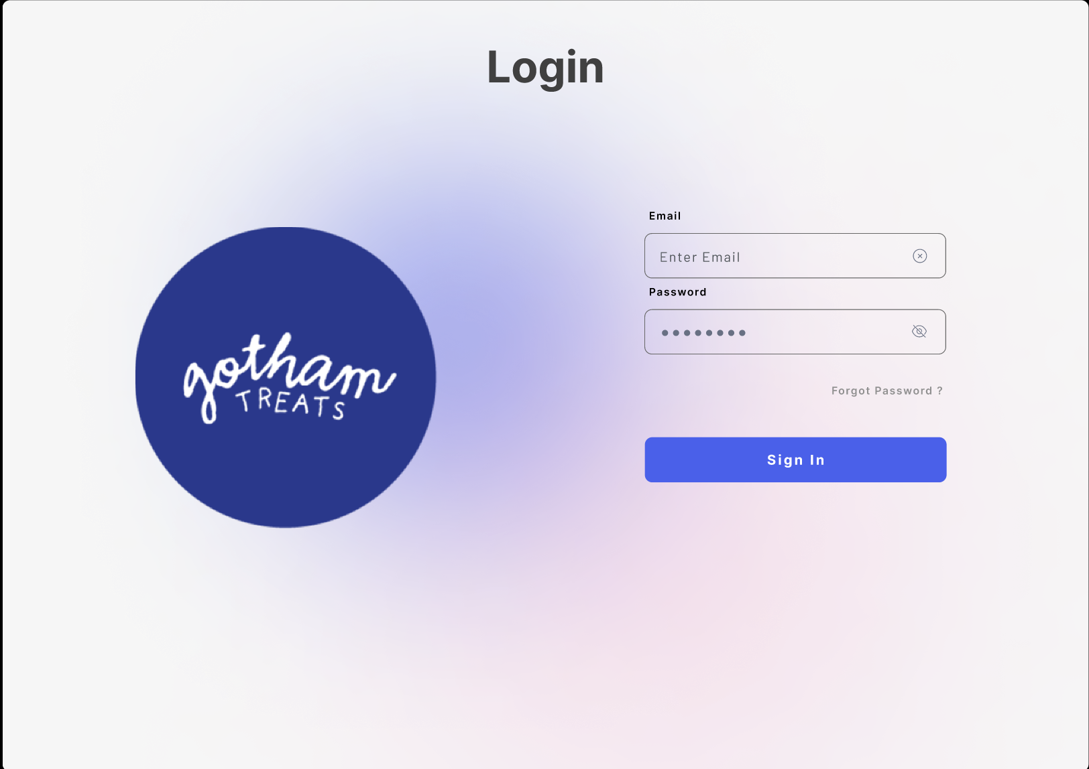

*Frame 1: Login Frame*

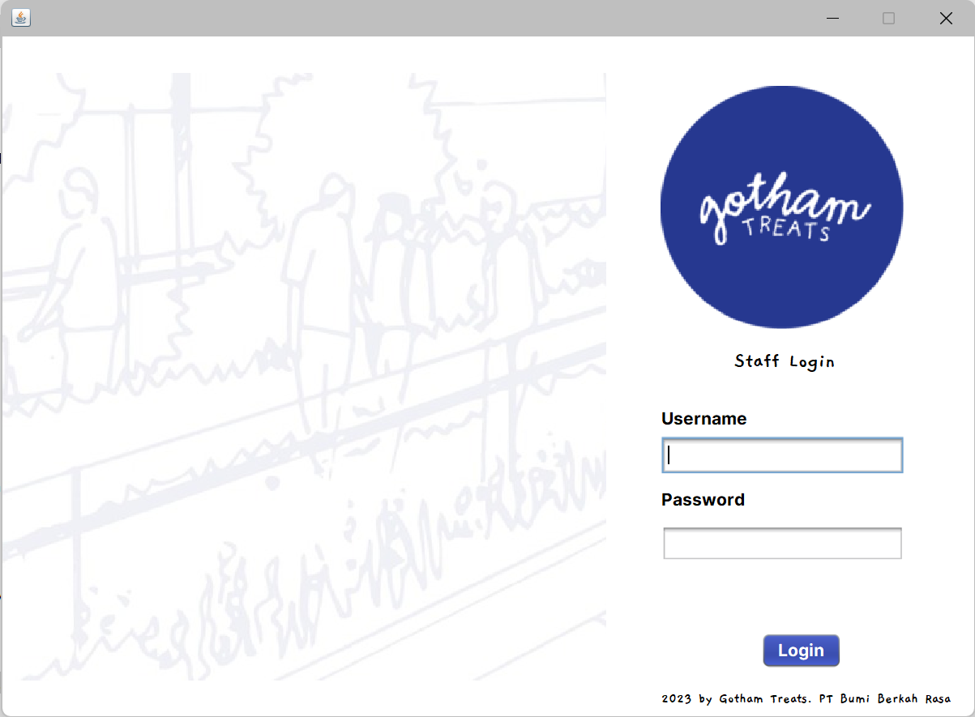

*Frame 2: Main Dashboard*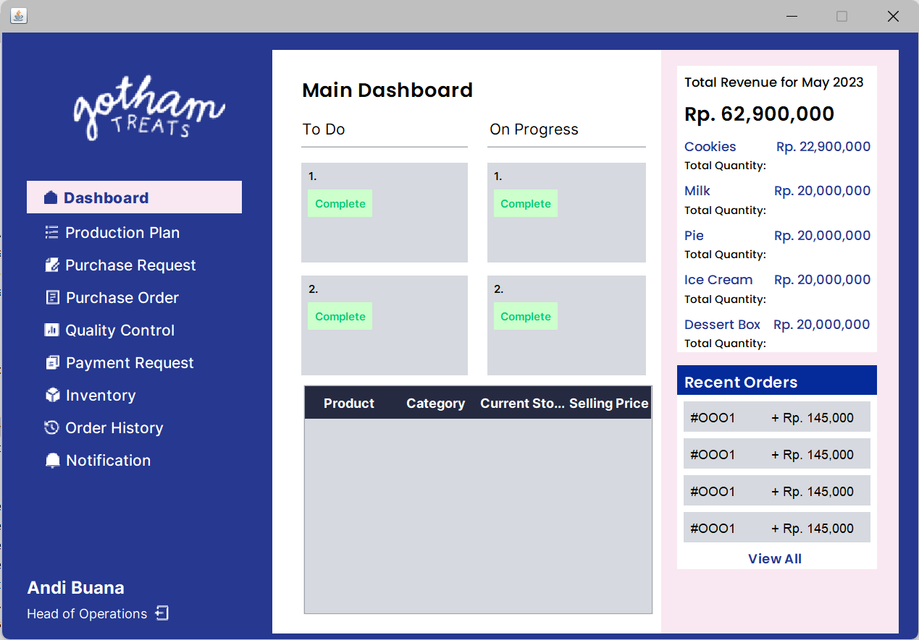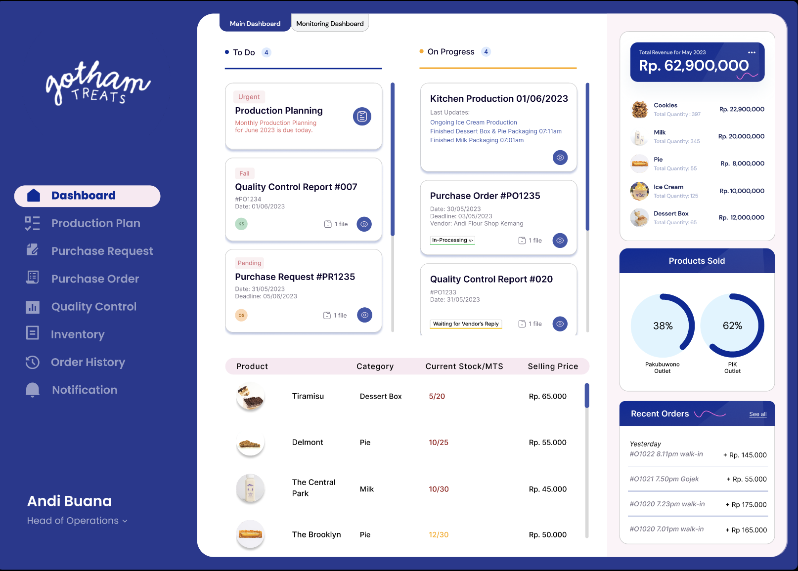

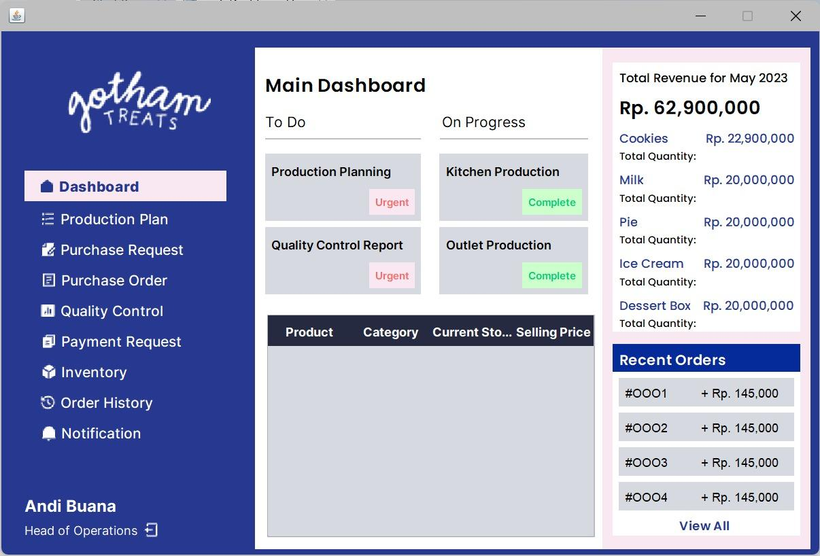

*Frame 3: Monitoring Dashboard*

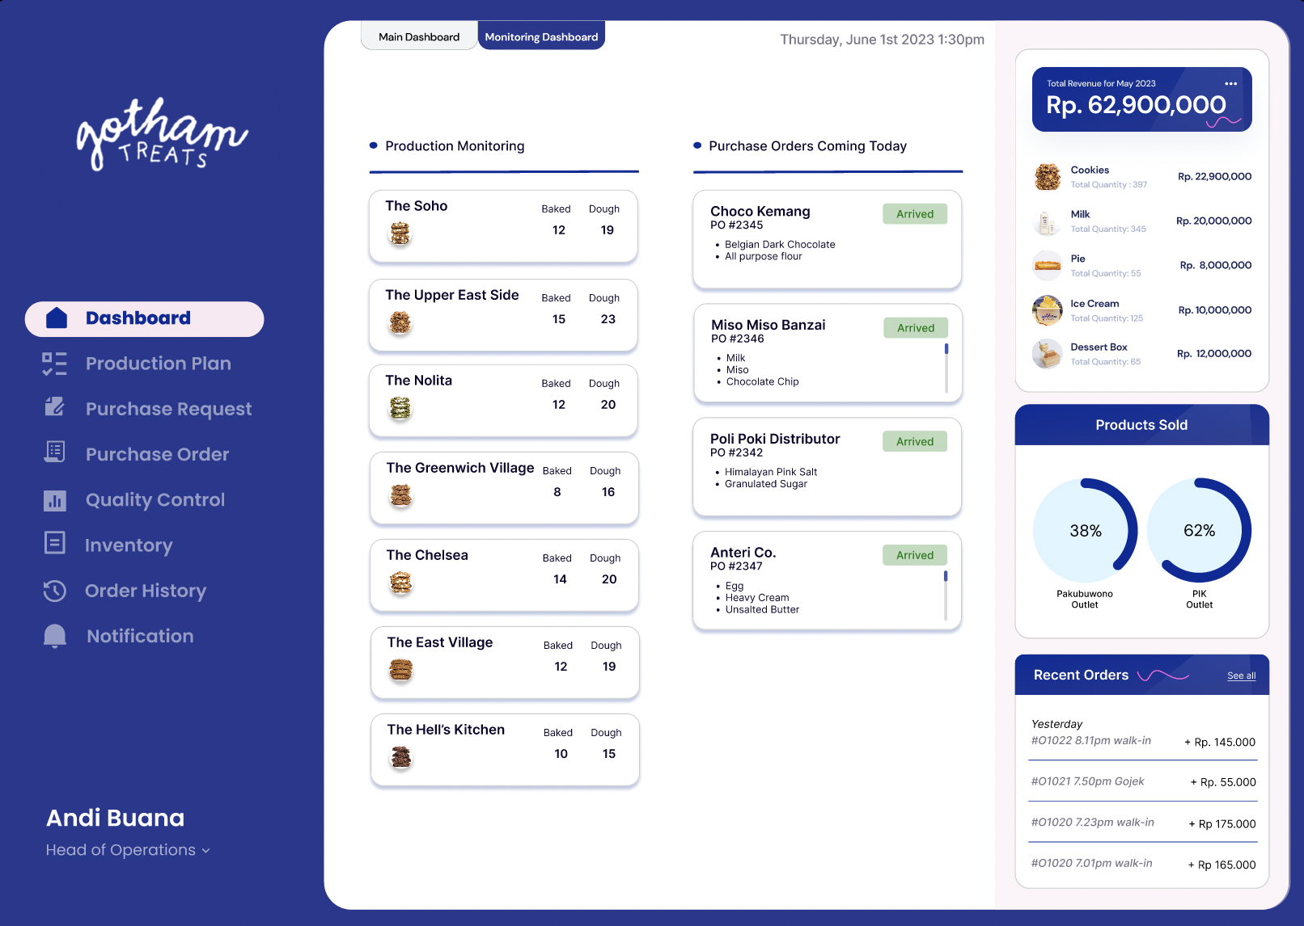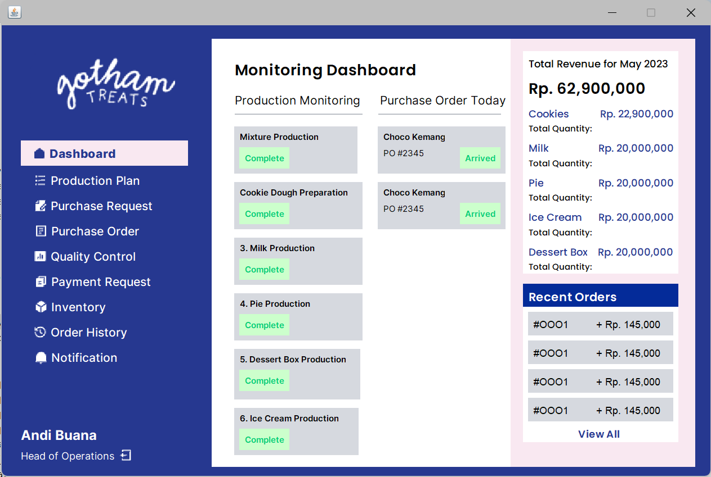

*Frame 4: Production Planning Step 1 Frame*

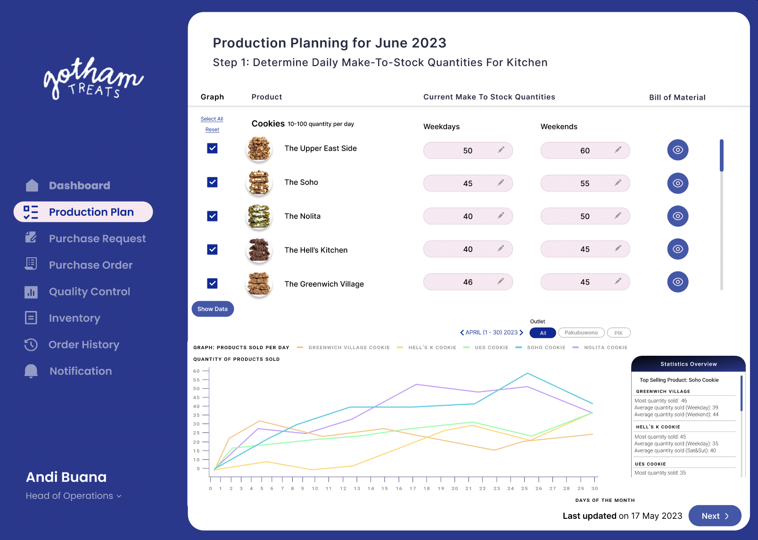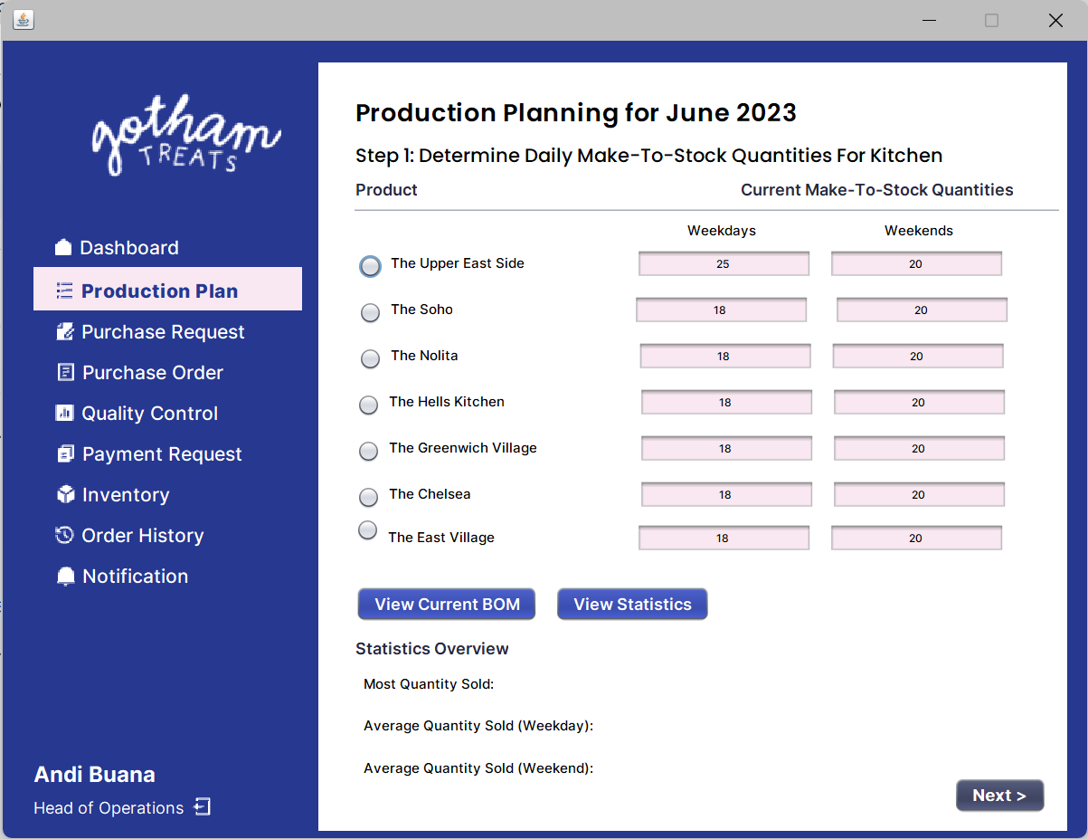

*Frame 5: Production Planning Step 2 Frame*

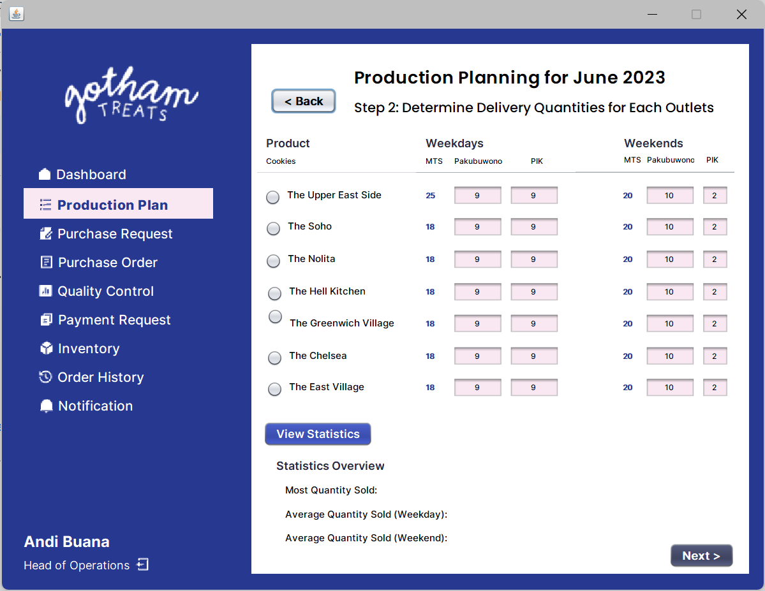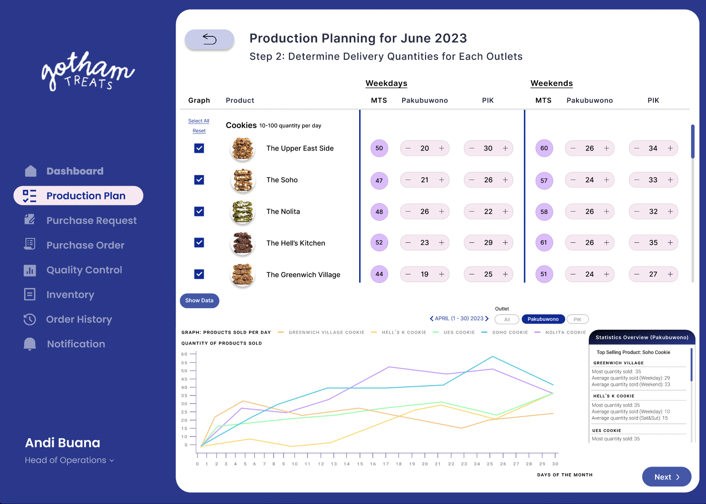

*Frame 6: Production Planning Step 3 Frame*

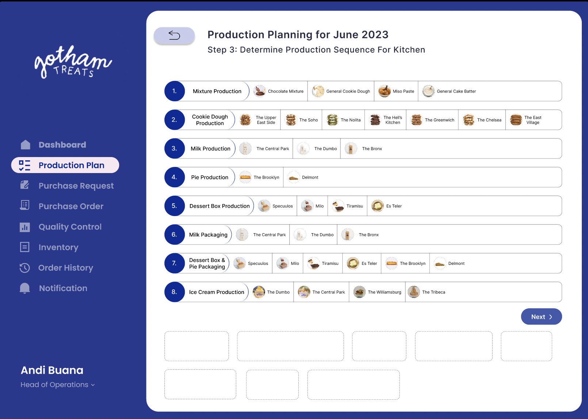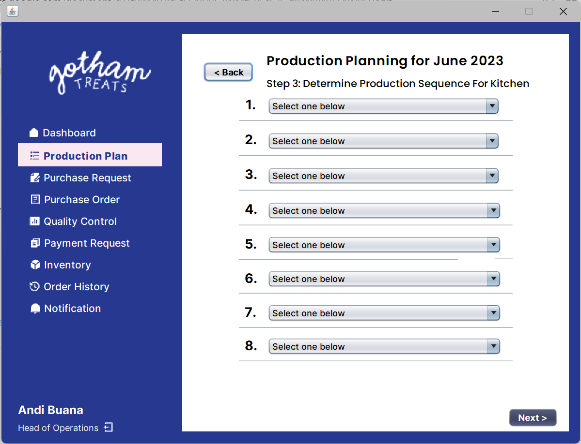

*Frame 7: Production Planning Step 4 Frame*

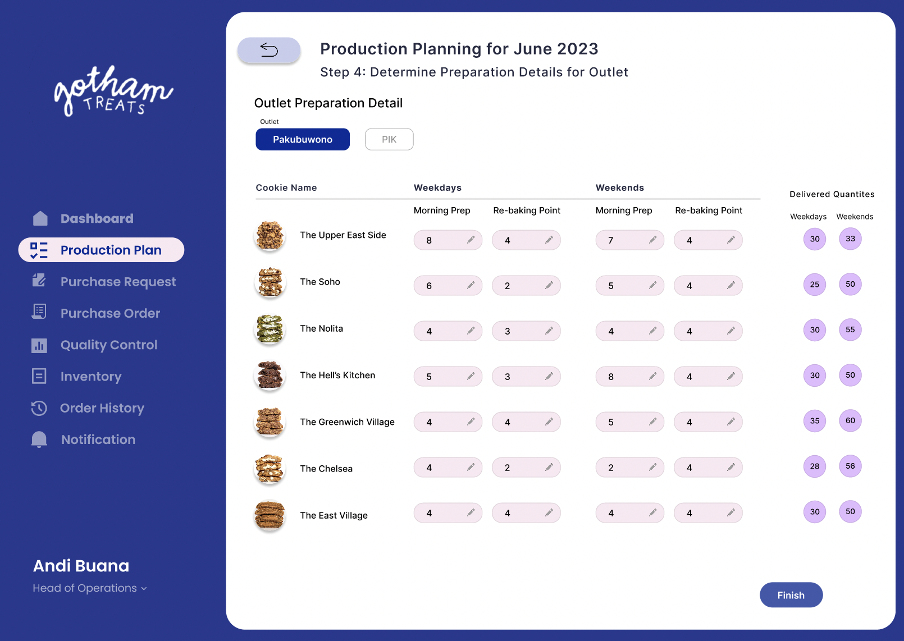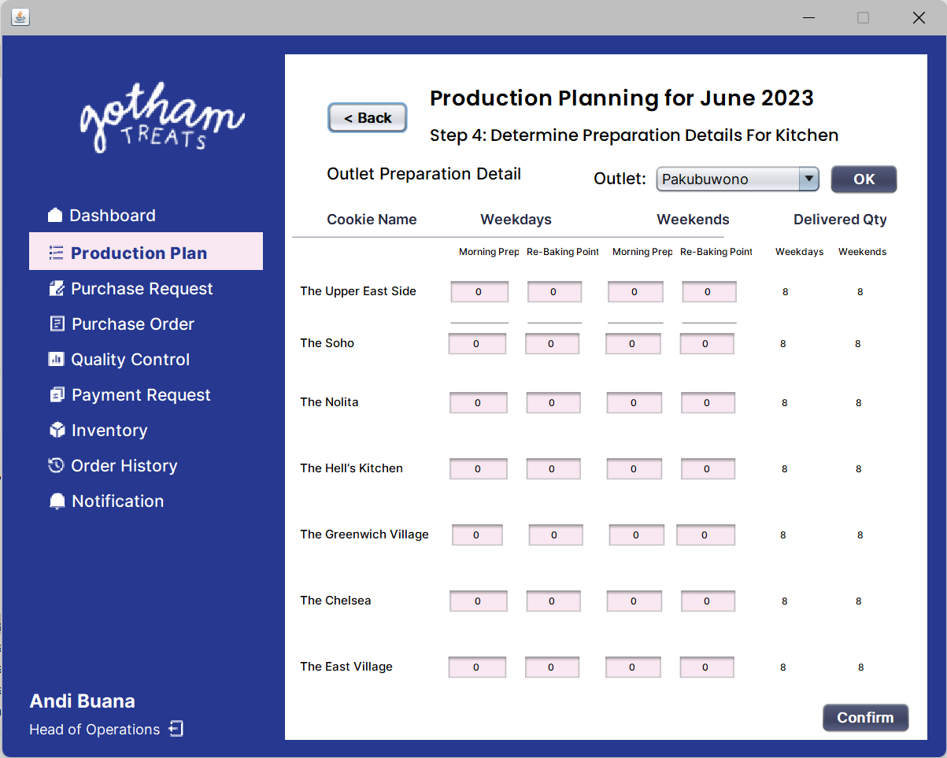

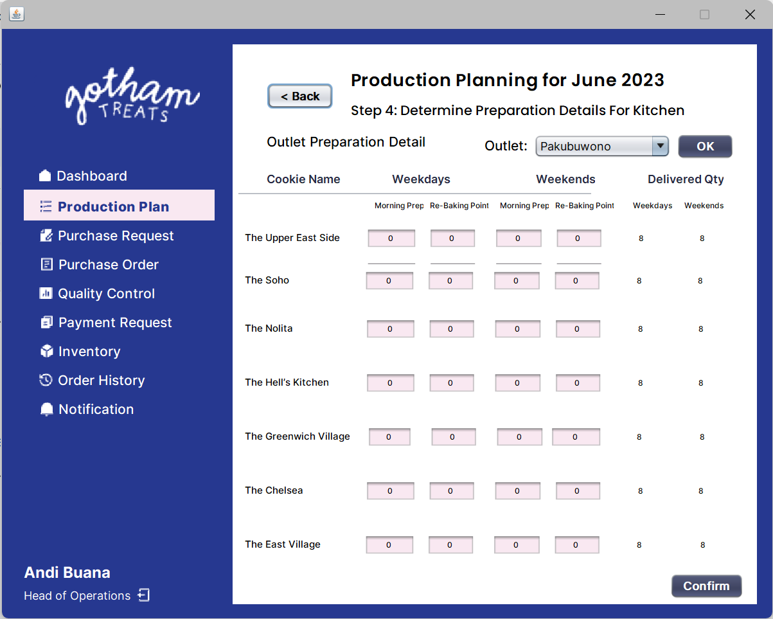

*Frame 8: Purchase Request Frame*

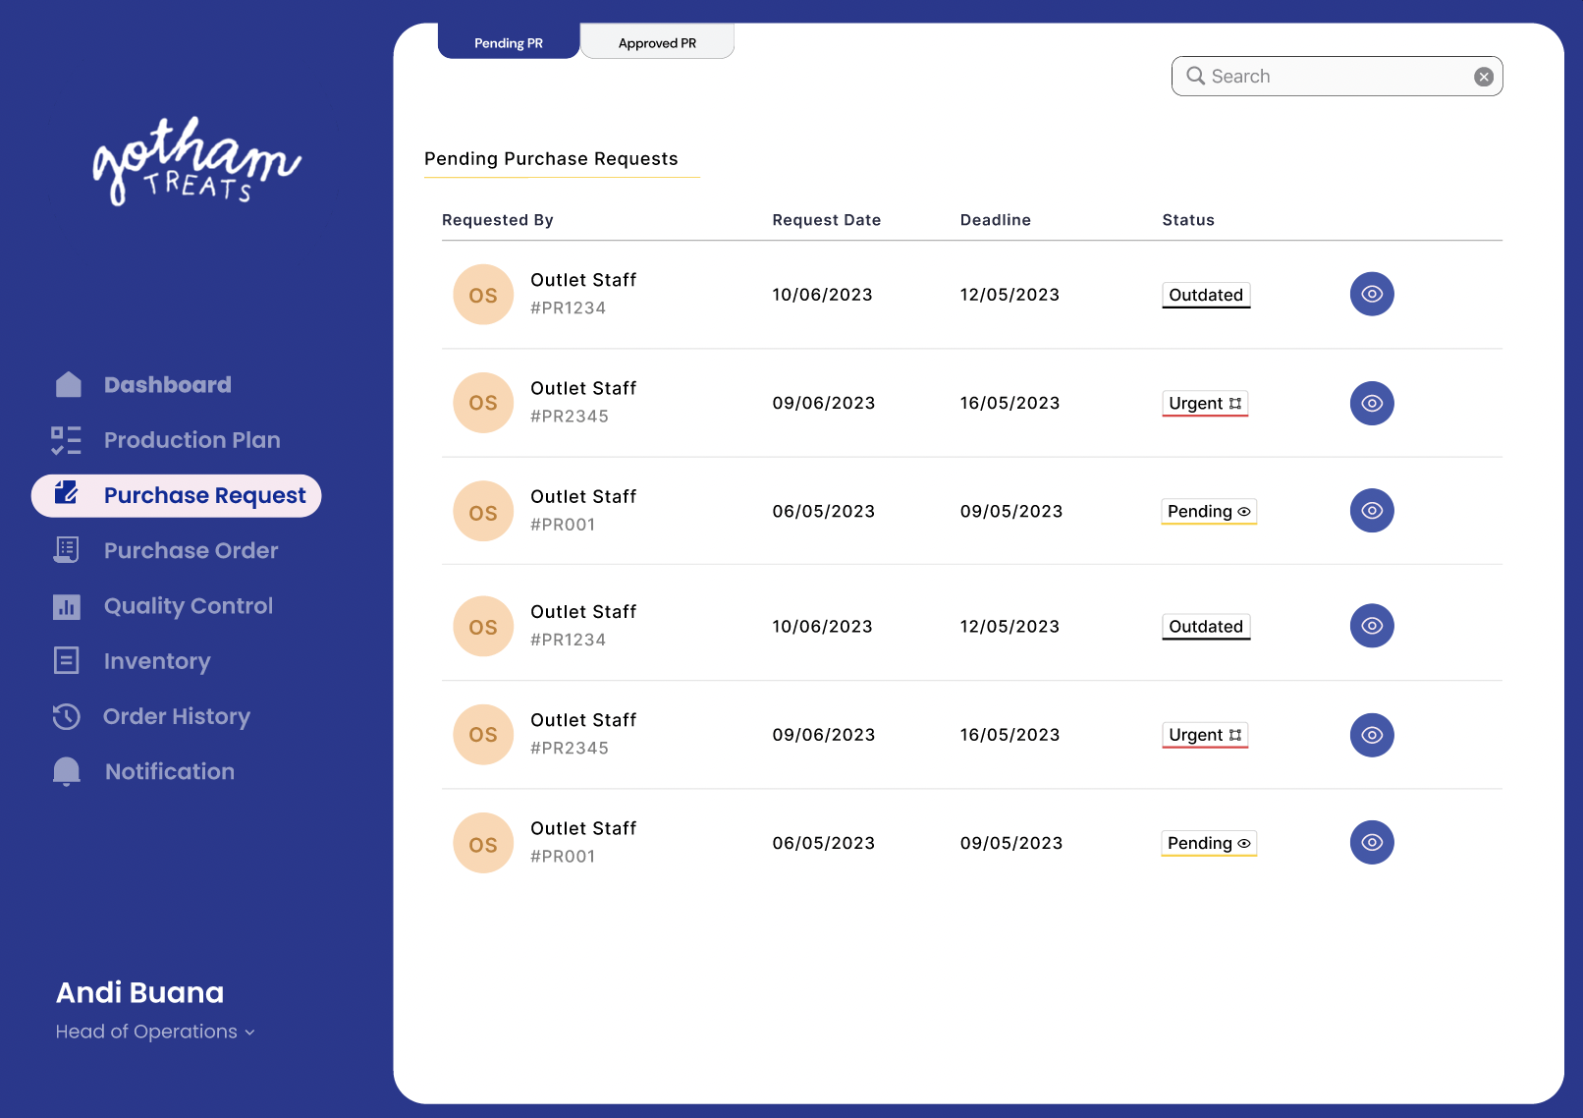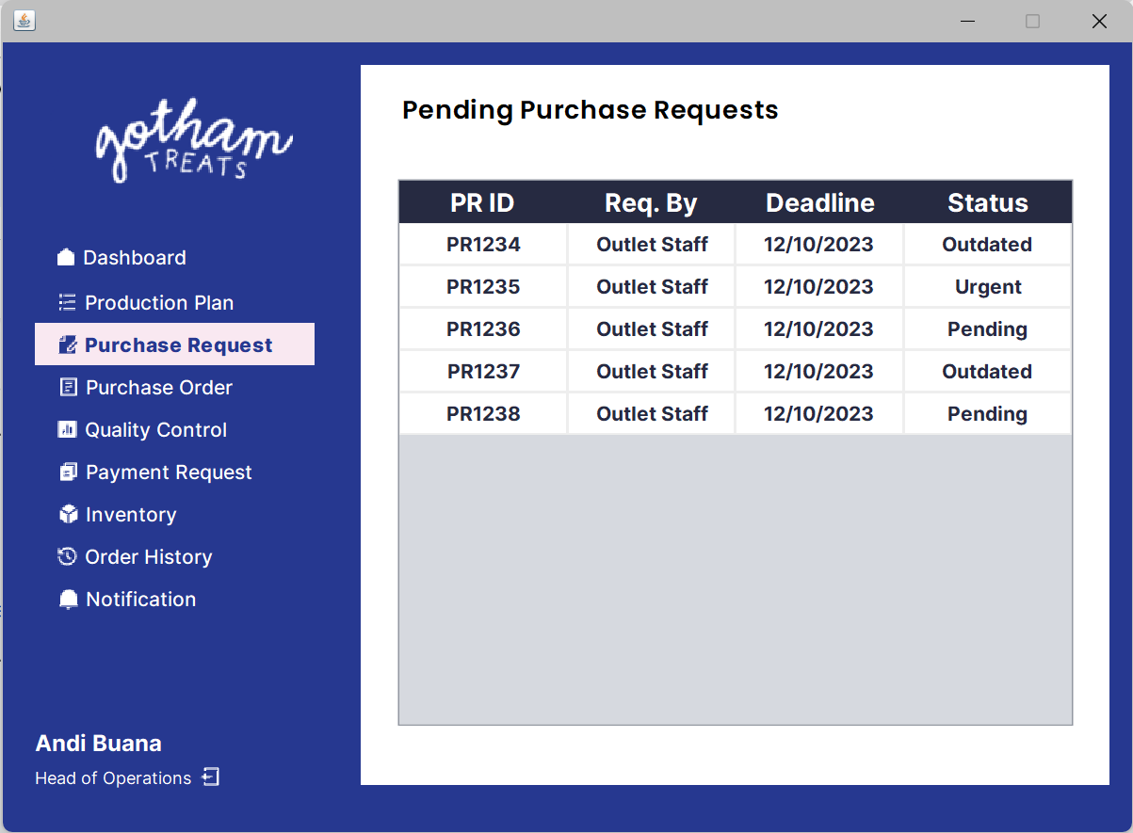

*Frame 9: Order History Frame*

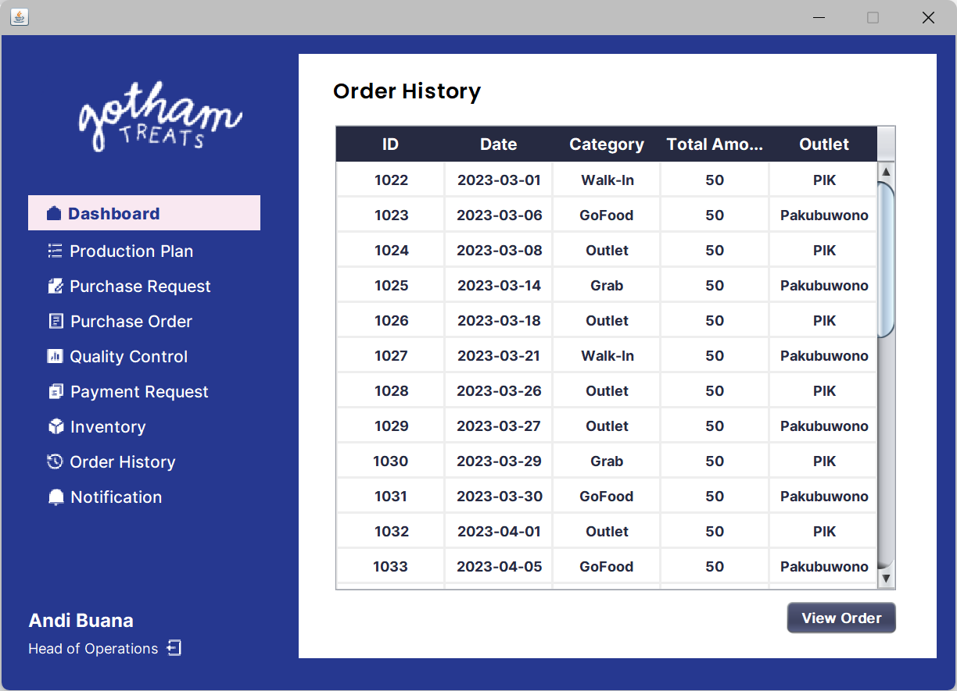

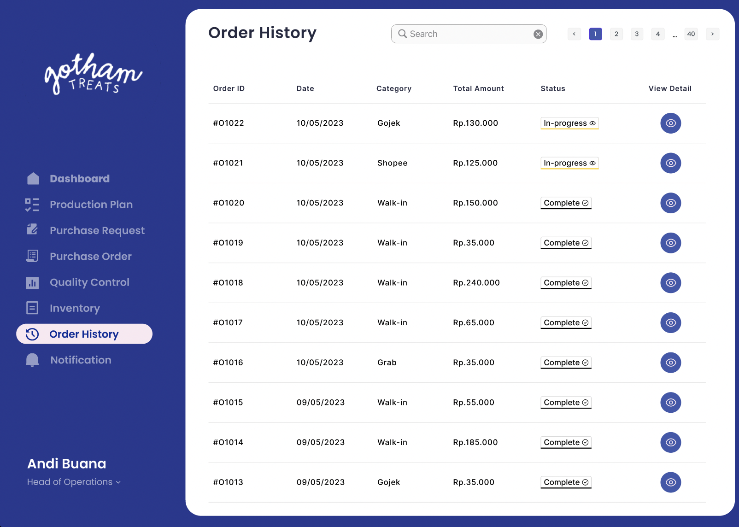

*Frame 10: Order Detail Frame*

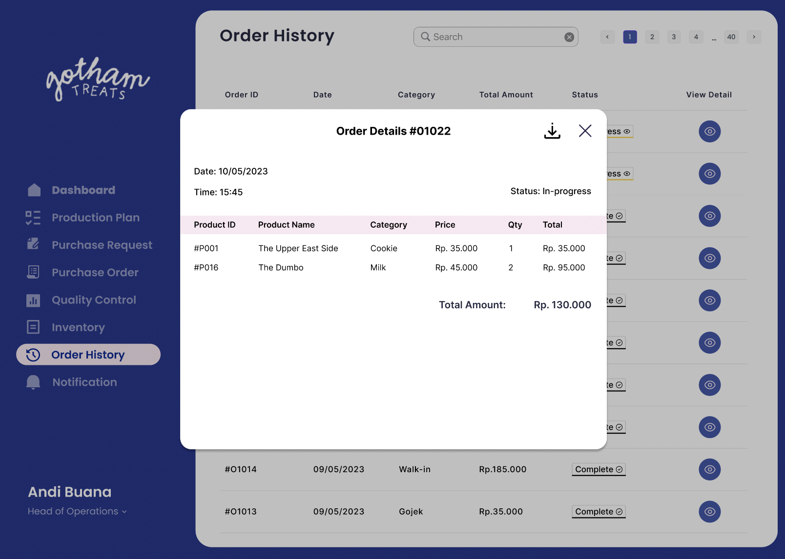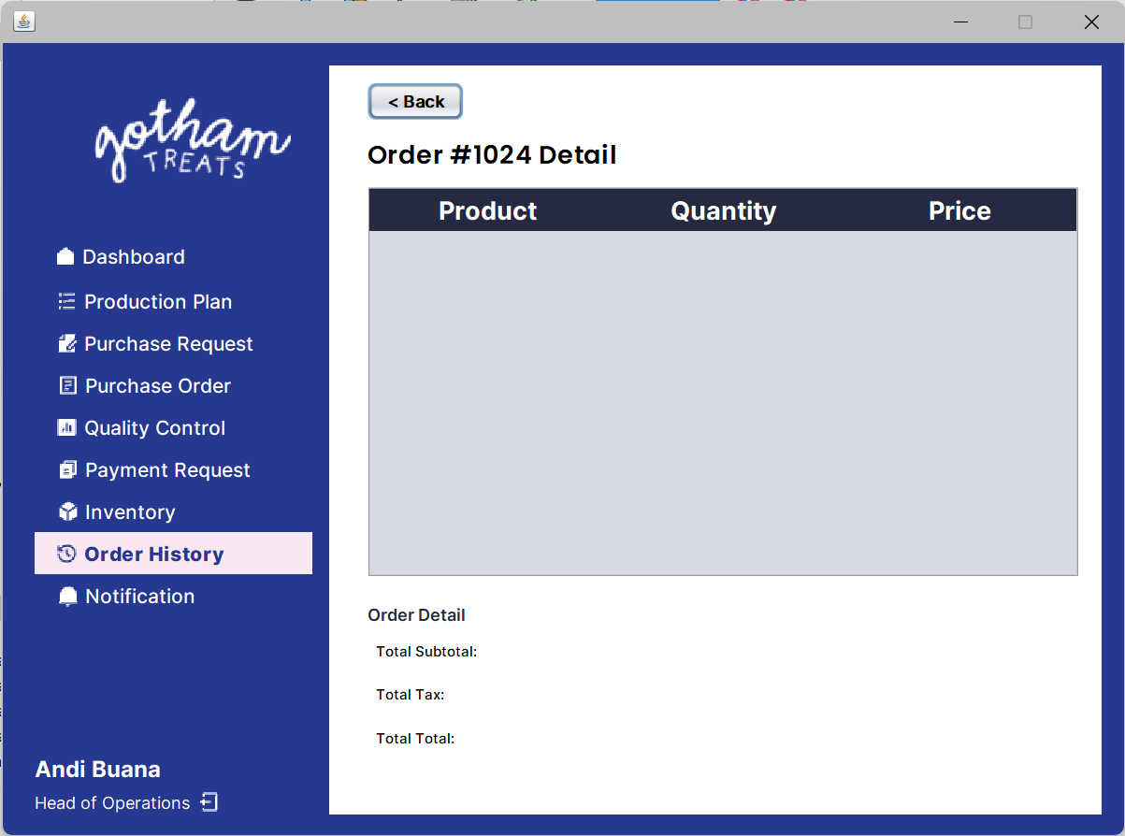

*Frame 11: Purchase Order*

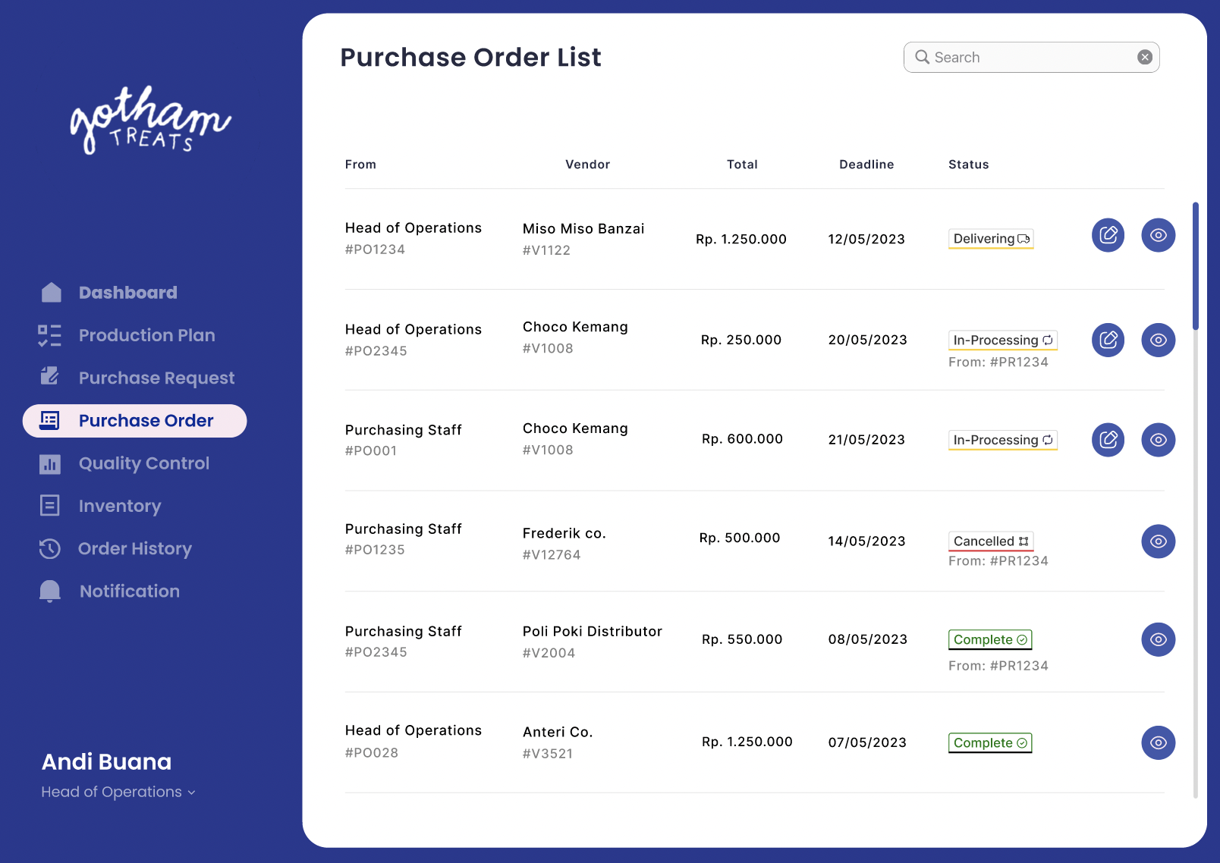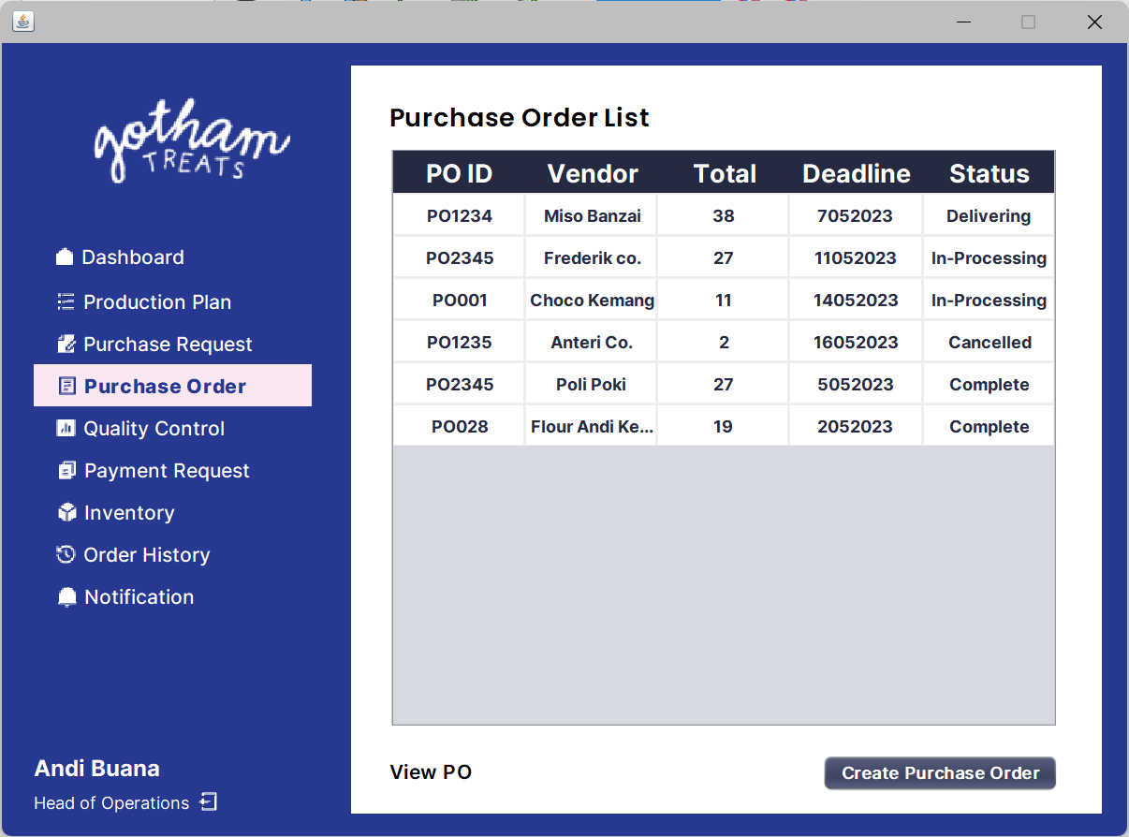

*Frame 12: Purchase Order Detail*

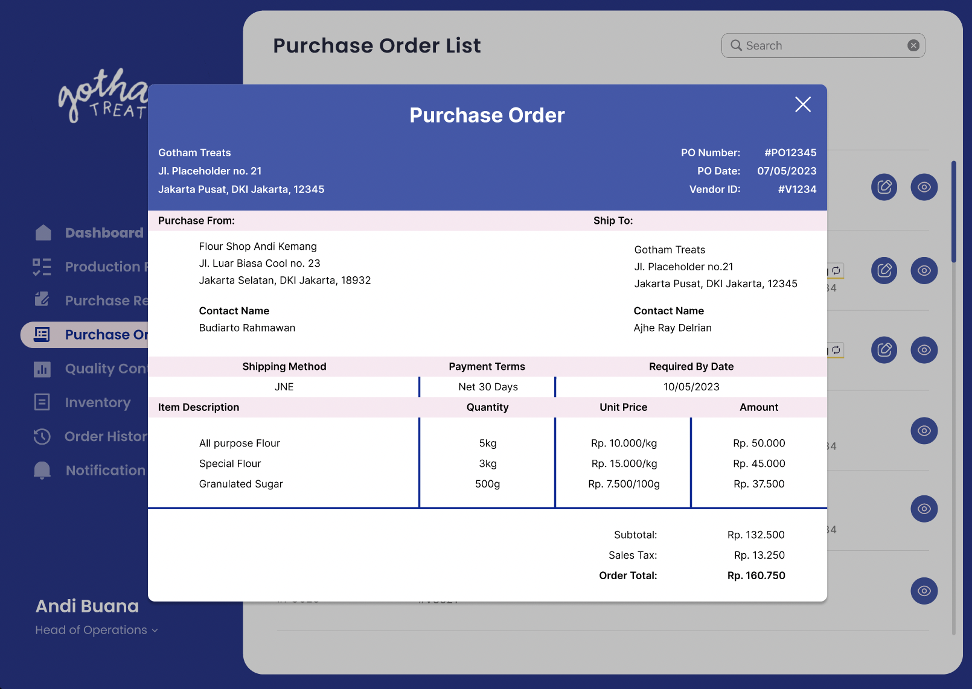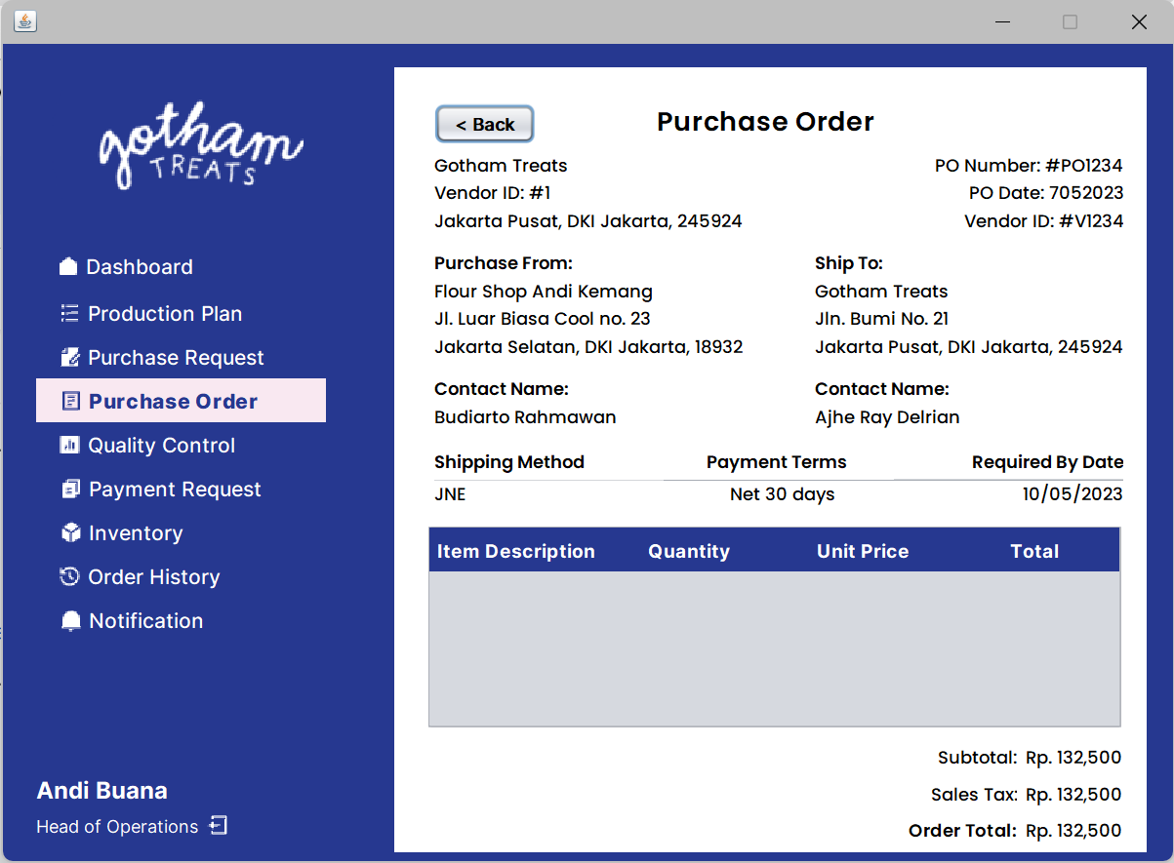

*\*

*Frame 13: User Detail*

## 

## 

## 4.7. Object Oriented Programming

For object-oriented programming, there are 11 classes that are instantiated within the programming project which are Cookie.java, Material.java, Order.java, OrderDetail.java, Product.java, ProductionStep.java, PurchaseOrder.java, PurchaseOrderDetail.java, PurchaseRequest.java, User.java, Vendor.java. The four main theoretical principles and concepts of OOP are encapsulation, inheritance, abstraction, and polymorphism.

From OOP terms, a class is a user defined blueprint or prototype from which objects are created. It represents the set of properties or methods that are common to all objects of one type. Classes are required in OOPs because they create efficiency and allow easier execution. In addition, OOP allows the code to be more structured and ensures that the DRY principle is applied, leading the code to be easily maintained and debugged.

1. Encapsulation

Encapsulation is one OOP concept that is used to protect sensitive data from the user and hide it accordingly. This can be seen by the fact that the variables and attributes in the class are private. Getter and setter methods are developed and are set as public methods in which enables access to get (read) and set (edit) on those private variables instantiated earlier.

By applying encapsulation in the Java code, it strengthens data security for the variables and attributes set in the class as they are set private and only accessible in the class. With the public methods of Getter and Setter, only specific attributes are able to be called outside the class. This can be seen by how all the classes have Getter methods in which are used to access and return a specific variable from the class onto the Controller as many of the Controller methods include Getter methods of a specific class.

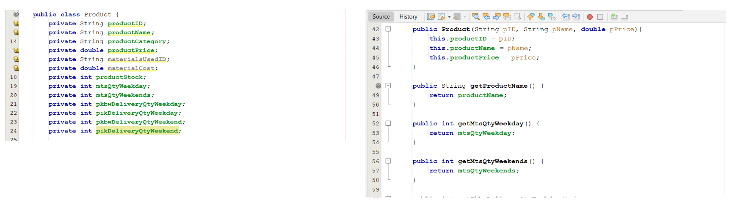

*Product.java class*

In the figure above, it can be seen that the Product Class has private variables and attributes along with Getter methods to access and return specific variables. Example is in line 13, private String productName is created in which that specific variable of productName is instantiated as a private variable. With line 48, a public Getter method is developed, public String getProductName(), whichthen returns the variable of productName. That is one example of how Polymorphism is applied and that is applied throughout all the model classes.

1. Inheritance

Inheritance is an OOP concept where a subclass (child) inherits from a superclass (parent) and brings the same attributes and methods from the superclass onto the subclass. Inheritance is specifically applied in this programming project by how the Cookie class inherits all the attributes from Product class but Cookie class still has some unique attributes that make them different from their parent class. In this case, the child is Cookie class which brings the same attributes from the Product class, which acts as the superclass.

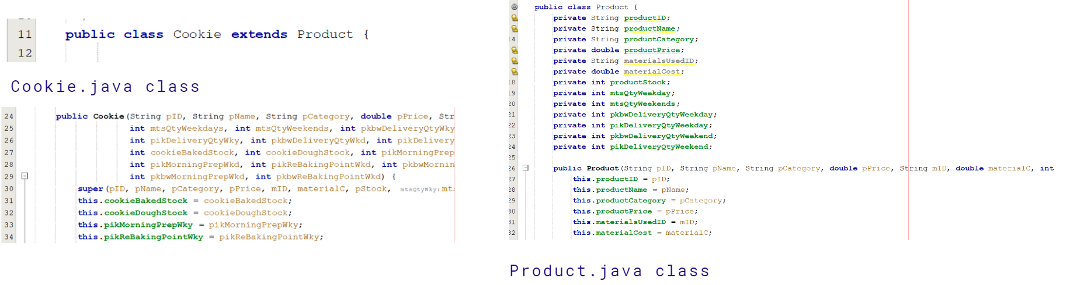

Cookie.java class and Product.java class

The Cookie class inherits various attributes such as productID, productName, productCategory and so on from Product class and that can be seen from line 30 with the keyword “super” used. However, like said before, the Cookie class has its own unique attributes such as cookieBakedStock, cookieDoughStock, pikMorningPrepWky, and so on which is only relevant to the Cookie class and not the Product Class. Cookie class and Product class is a clear example of how inheritance is showcased in the programming.

1. Abstraction

Abstraction concept is in which certain data variables are hidden and only the essential data are accessed and read to the user. The concept can be implemented in programming through abstract class or interface.

Interface is in which an abstract class is created and filled with public methods that contain empty bodies or empty lines of code that are necessary for a class to implement. It serves as a blueprint in creating classes. Interface is used in programming specifically with the PurchaseRequestInterface.java and PurchaseOrderInterface.java in which they both serve as a blueprint for the class PurchaseRequest.java and PurchaseOrder.java respectively.

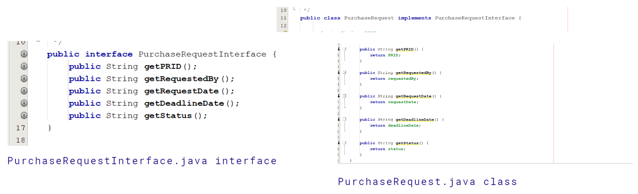

PurchaseRequestInterface.java Interface and PurchaseRequest.java class

Above is an example in which PurchaseRequest.java class implements from the PurchaseRequestInterface.java

1. Polymorphism

Polymorphism is an OOP concept that is used to perform an action through different ways and supports method overriding (runtime polymorphism) and method overloading (compile-time polymorphism).

In programming, overriding is in which a subclass has its own personalised implementation of a method that is different from the method that is defined in the superclass. The overriding method enables a subclass to have its own personalised and unique implementation of a method. This method is a runtime polymorphism where the method that is being executed will be evaluated based during runtime, when the code is being runned.

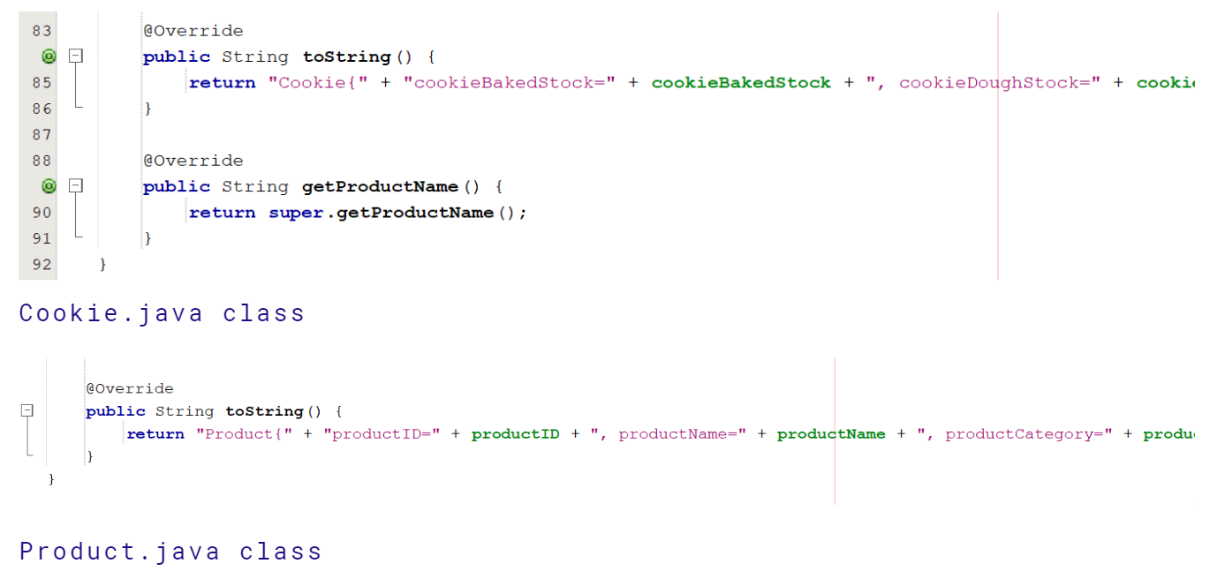

Cookie.java class and Product.java class

With the Cookie class inheriting from Product class, it leads the Cookie class to be a subclass from the superclass of ProductClass. Cookie class carries the same method name of toString() but returns a unique and different text than the return of toString() from the Product class. Therefore the toString() in the Cookie class is an overriding method as that subclass has its own personalised implementation of method toString() that is different from the method toString() in the superclass, Product class.

## 4.8. Reusability Techniques

In programming, reusability is often emphasised as developers themselves do not want to write lines of code that are redundant and repetitive. Hence through the use of object-oriented programming and reusable methods instilled into the programming project, developers are able to reuse and reference those methods multiple times. Therefore, code reusability is able to be achieved through Java by OOP along with methods contained in one DataAccess class and one Controller class.

# 

# 

# **Chapter V: Closing**

## 5.1. Conclusion

In conclusion, through our programming final project, we are able to develop and build a Java Desktop application aligned with our solution for Gotham Treats as an inventory management system. By utilising object-oriented programming and integrating a database with the use of XAMPP, we were able to make our application efficient and reliable with the data storage, the maintainability of classes and reusability of methods. By providing a user-friendly graphical user interface along with CRUD operations, the end user, the Head of Operations for Gotham Treats, is able to perform the tasks and interact with the application effectively to meet and satisfy their needs.

## 5.2. References

Cyubahiro, P. (2022, April 18). *Object-Oriented Programming in Java – A Beginner’s Guide*. FreeCodeCamp.org; freeCodeCamp.org. <https://www.freecodecamp.org/news/object-oriented-programming-concepts-java/>

*Java OOP (Object-Oriented Programming)*. (2023). W3schools.com. <https://www.w3schools.com/java/java_oop.asp#:~:text=OOP%20helps%20to%20keep%20the,code%20and%20shorter%20development%20time>

*MVC Framework Introduction*. (2022, March 21). GeeksforGeeks; GeeksforGeeks. <https://www.geeksforgeeks.org/mvc-framework-introduction/>

*Understanding Classes and Objects in Java*. (2018, September 11). GeeksforGeeks; GeeksforGeeks. <https://www.geeksforgeeks.org/understanding-classes-and-objects-in-java/>